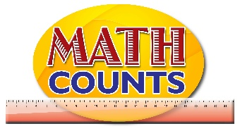

National Mathematics Team
Grade 1 - Planning Sessions Template
Strand: Numbers
Topics/Objectives | Main Concept | Teaching/Learning Activities | Assessment/Homework Activities
Identify counting and whole numbers  Know the doubling facts  Count by 2 to at least 20 | Whole number  Counting Number  Double  Least  Even numbers | Identify counting and whole numbers  Activity 1  - Share a poem with students and have them recite it: “One, Two, Buckle My Shoe”. (See Resource document for sample). Have students go through the poem a second time. This time as they ‘count’, record the numbers from the poem on the board up to 10.  Activity 2  - Draw a large circle on the board. Place 10 magnetic shapes (or otherwise – use tape to hold shapes to the board) on the outside of the circle.  - Have students view the circle and objects. Inform the students that they will be counting and recording the number of objects that are in the circle at a given time.  Guided Questions  How many shapes are on the inside of the circle? None, nothing, zero.  How can we represent that? 0.  - Record the response on the board (be sure to place it under the whole numbers that were already identified from the poem.  - Place 1 shape in the circle and ask students to count the number of shapes. Record this as 1.  - Repeat this process until all the shapes are in the circle and the associated numeral recorded. At the end of the activity the following should be on the board.  0, 1, 2, 3, 4, 5, 6, 7, 8, 9, 10  1, 2, 3, 4, 5, 6, 7, 8, 9, 10  Guided Questions  Look at both sets of numbers. What do you notice that is the same about them and what is different?  As a class, create a definition of the terms - Counting numbers and Whole numbers – place label and example on your Word Wall  Counting Numbers  Counting numbers are….  Example: 0, 1, 2, …  Know the doubling facts  Activity 1  - Give each child a set of unifix cubes or blocks and a card with a numeral from 1-10. Ask students to make a tower with the number on their card. Then have them make another tower with the same number of blocks. (See example of tower below)  Guided Questions  What number is on your card? How many cubes did you add to your set? How many do you now have in all?  What is the relationship between the number you started off with and the number you now have? What word could you use to represent it? Double.  - Provide students with a worksheet and have them test if this ‘rule’ holds true for other numbers.  (see resource document for a sample)  - Have a discussion with students regarding objects that appears in twos: eyes, hands, legs, ears, twins, bicycle wheels, dominoes and so on.  - Share a story "Double the Ducks" by Stuart J. Murphy to the class while modelling it (See YouTube link https://www.youtube.com/watch?v=hnRT0HSzvAg).  - At strategic points as guided questions.  If each duck brings back a friend, how many ducks are there now? If the farmer has doubled the hay, how many did he have at first?  After reading the story, ask the students what they thought of the story and what they learned from it.  - What are doubles?  - Why did the farmer have to double everything?  - How did he use doubles to make his work easier?  - What would have happened if the farmer had to triple everything?  Activity 2  Have students work in pairs to populate the Domino Doubles Mat (see Resource document for the mat and domino samples).  Have students look on the mat and identify a number. For example 3. Then have them suggest the result if the number is ‘doubled’ – 6. Encourage students to look for a domino that has ‘3’ doubled and place that domino in the corresponding position. To confirm that their domino is in the correct position, students should count the number of dots and ensure that it is adds up to 6.  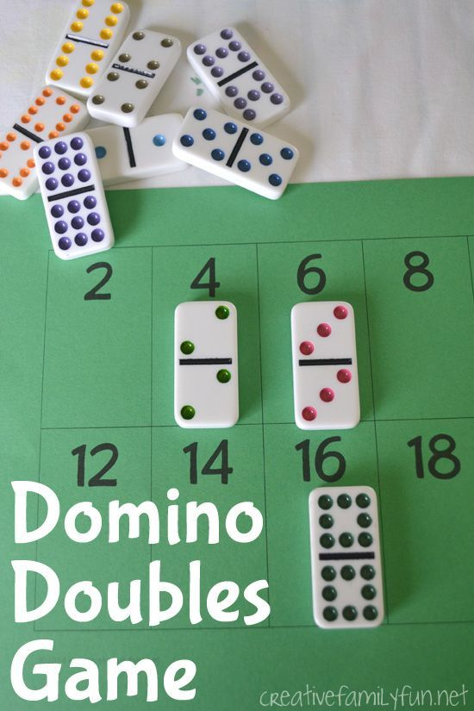  Count by 2 to at least 20  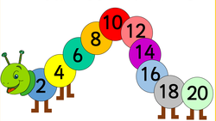  - Create circular number cards like those above – ranging from 2 to 20. Have students place them in order beginning with the smallest and encourage them to report their observations.  Guided Questions  What do you notice about the numbers on the cards? Why do you think so?  - Provide students with a Hundred Chart and have them investigate to find the numbers that are missing. Have them identify the numbers on their cards on the Hundred chart and share their observations.  - Have them count by 2 and encourage them to ‘suggest’ the next number in the series.  - As a whole group, provide them with scenario such as the following:  Scenario 1  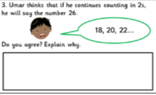  Scenario 2  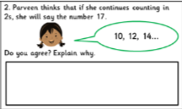  See Resource Document for sample scenarios. | Identify counting and whole numbers  Card Sort  - Place students in groups of fours and give each group a set of number cards with numbers from 0 to 10.  - Have one person in each group, shuffle all the cards and distribute eleven cards to each person.  - One student will pass a card to the person beside him/her (decide the direction beforehand). The person who receives the card will check if he needs that card to complete his set or if the card is a duplicate. He will pass a card that he does not need for his set.  - Students will continue passing cards until one student completes the set.  - The first person to have all eleven numbers in order is the winner.  ICT Inclusion  Students will select the next number in the series  http://www.ictgames.com/whackAMole/index.html  The aim of this activity is to test whether students are able to select the next counting number.  http://www.ictgames.com/nutty_v3.html  Students will count from 1 to 10  http://www.ictgames.com/newduckshoot.html  Know the doubling facts  Activity 1  - Place students in pairs. Provide each group a sheet of paper and crayons. Have students fold the paper in half. Instruct one student to draw a set number of objects on one side of the paper.  - Have the partner draw the same number of objects on the other side of the paper.  - Together, the students will label their drawing and create an addition sentence describing their drawing.  For example, if one student draws 2 stars on the left side, then the other student draws 2 stars on the right side, their addition sentence would be 2+2=4.  Activity 2  Place students in groups of fives and provide each group with the game “Slides and Ladders”. (See Resource Document for game)  ICT Inclusion  Robin Hood archer game is for students to select the double number shown.  http://www.ictgames.com/robindoubles.html  Aim of the activity is for students to create a double bridge correctly  http://www.ictgames.com/bridgedoubles.html  Count by 2 to at least 20  Provide each student with a laminated hundred chart and markers. Have students begin at the number 2 and skip count by 2, placing a marker on each number. See resource document for sample hundred chart.  ICT Inclusion  The aim of this activity is for students to select the correct number.  http://www.ictgames.com/fairyfog2s_v2.html

