The Financial Institution Game (Week 1 Assessment, # 2)

Materials:
- Cards with different transactions. Example: deposit, loan interest paid, loan interest received, interest received, ATM withdrawal. POS (Point of Sale) purchase
Loan Interest paid 40.73
Interest received 96.02
Atm withdrawal 850
Deposit $1500. 20
Withdrawal $700.

POS $ 600

- Scoring card for each player
Rules & Procedures
- Shuffle game cards and place them face down.

- Each player should have a scoring card to record his transactions and an account balance of a stated amount e. g $3000.00 written at the top of the scoring card. A banker is needed to oversee transactions

- Players will take turns selecting transaction by using the cards on the pile. Each transaction of each player should be recorded on the scoring sheet and reflected in their balance. The banker will verify the transaction.

- Each card used will be placed in the discarded pile.

- The game ends when all the cards have been drawn and the person with the largest remaining balance wins the game. (Note well, when a player has used up all the money within his account he has to hand in his account and leave the game) (scoring card)

Extension:
The game may be extended to include withdrawals and loans and service charges etc.

Rubric for Project (Week 1 Assessment, # 1)
Areas | Beginning  1 point | Developing  2 points | Accomplished  3 points | Exemplary  4 points
Contribution | One or more members do not contribute. | All members contribute, but some contribute more than others. | All members contribute equally. | All members contribute equally, and some even contributed more than was required.
Information  - Named institution  - Roles and functions  - Relevant examples of Transactions  - Visual/Graphic representations | Insufficient information presented about the named financial institution | Adequate information presented about the named financial institution | More than the required amount of information presented about the named financial institution | Comprehensive information presented about the named financial institution
Cooperation | Teacher intervention needed often to help group cooperate. | Members work well together some of the time. Some teacher intervention needed. | Members work well together most of the time. | All members work well together all of the time; assist others when needed.
On task | Team needs frequent teacher reminders to get on task. | Team is on task some of the time. Needs teacher reminders. | Team is on task most of the time. Does not need any teacher reminders. | Team is on task all of the time.  Does not need any teacher reminders.
Communication | Members need frequent teacher intervention to listen to each other and speak to each other appropriately. | Members need some teacher intervention to be able to listen to each other and speak to each other appropriately. | All members listen to each other and speak to each other in equal amounts. | Each member listens well to other members. Each member speaks in friendly and encouraging tones.

Hundred Grid (Week 2-3 Teaching and Learning Activity, # 2)

Multiplication of Whole numbers to Decimals (Week 2-3 Teaching and Learning Activity, # 4)

Multiply 232 x 1.2
Step 1:
Expand the two numbers:
232: 1.2:
(200 + 30 + 2) (1 + 0.2)

Step 2:
Multiply each number in the expansion of 232 to 1:
200 x 1 = 200
30 x 1 = 30
2 x 1 = 2

Step 3:
Multiply each number in the expansion of 232 to 0.2:
200 x 0.2 = 40.0
30 x 0.2 = 6.0
2 x 0.2 = 0.4

Step 4:
Add all the products in steps 2 and 3 together:
H | T | O | DP | Tenths
2 | 0 | 0 | .
 | 3 | 0 | .
 |  | 2 | .
 | 4 | 0 | . | 0
 |  | 6 | . | 0
 |  | 0 | . | 4
2 | 7 | 8 | . | 4

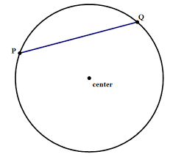
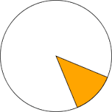
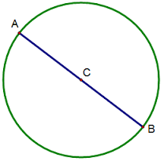
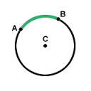
Cut outs for parts of the circle ( Teaching and Learning Activity, # 1)

