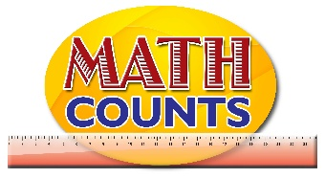
National Mathematics Team
Grade 1 – Planning Sessions Template
Topics/Objectives | Main Concept | Teaching/Learning Activities | Assessment/Homework Activities
Use concrete materials to investigate the relationship between the size of a unit and the number of units needed to measure length.  E.g. compare the number of paper clips and pencils needed to measure the length of a table. | Compare  Measure  Estimate / guess  Length  Long, longer  Longest  Short, shorter, shortest  Units  Size of unit  Number  More  Less | Activity 1  Use non-standard units such as pencils of the same length and paper clips to measure the length of particular objects such as a table, and have students compare their units. Guide the activity by asking the following questions:  - Which unit did you need more of? Why do you think this is so?  - Which unit covers the length faster/est?  - How many of the smaller units are close to one of the larger unit?  - About how many of the smaller units would give 2 of the larger units? (Let students count on)  Extension: Allow students to discuss why they think the answers differ.  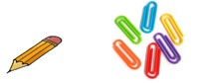  Ensure the units of measurement are used in students’ responses.  Example: 5 pencils long and 15 paper clips long.  - Place students in groups and give them manipulatives (e.g. cubes , paper clips and counters,). Have them use the paper clips, counters and cubes to measure the 3 snakes’ See page 3 to 5 of the Resource Document, for extension of activity.  Activity 2  - Provide each student with a large sheet of paper. Instruct the students to use a marker or crayon to draw a line. Tell the students that the line that each one draws may be straight, wavy, zigzag, or curved  - Next, ask the student to choose from a variety of non-standard units (e.g., cubes, paper Clips, clothes pins,) one unit with which to measure the length of the line. Instruct them to estimate the length of the line, and to record their estimate beside the line (e.g., Estimate –25 cubes long).  - Next, have students use the chosen non-standard unit to measure the actual length of the line. Have them record the actual measurement (e.g., Actual – 23 cubes).  Observe students to see how well they complete the task. Use the check list on page 6 to assess the students. | Assessment 1  Have students engage in the Snake Measurement Activity on page 2 of the Resource document.  Assessment 2  ICT Inclusion  Chef Pierre Estimate and Measure - http://www.compasslearningodyssey.com/sample_act/math_k/grade/subject/mak_04_03_03.html

