NATIONAL MATHEMATICS PROGRAMME

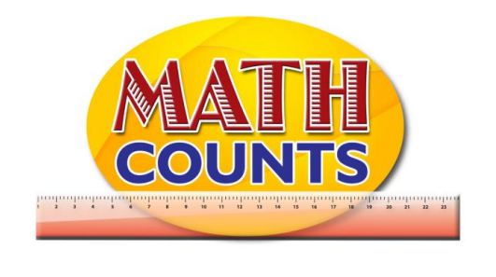

Resource Document
FOR GRADE ONE TEACHERS

Objective: Placing Numbers in Serial Order
Topic: Number Grid and Cards

Teachers can create their own grids and number cards. Despite the shape of the grid, students are expected to move from left to right along each row. Below are a few examples
GRIDS
1 |  | 3
 | 5
7 |  | 9

 | 2 | 3 |  |  | 6
7 |  | 9 | 10

Objective: Placing Numbers in Serial Order
Topic: Number Cards

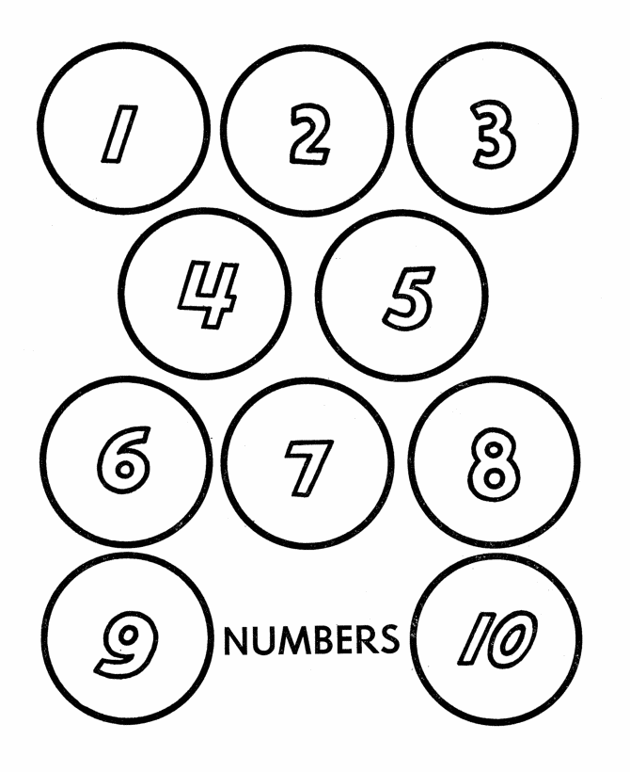

Objective: Use objects to create sets
Topic: Creating Sets

SETS
Set with Red markers | Set with Blue markers
Combined set

CREATE A SET
Set 1 | Set 2 | Set 3

Objective: Items that belongs/do not belong to a set
Topic: Attribute Blocks
This is a sample. Teachers can use the idea to create their own version of the Attribute blocks.
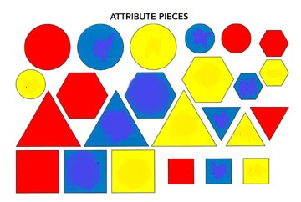
Objective: Identify Sets With Up To 19 Members
Topic: Sample Problem Solving Activities

Angie has 8 lollipops. She is deciding how many to give to her friend and how many to keep. What are the different choices that Angie could make?

- In a garden each bee need to land on a flower to collect its pollen.
- How many bees need flowers?
- Are there enough flowers for each of the bee to land on?
- Draw lines to match one flower to one bee.
- How many more flowers are needed?
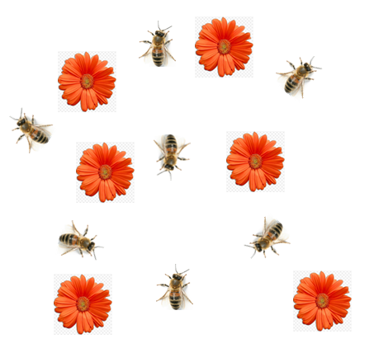

Objective: Partition 2 – 10 members in two or more sets
Topic: Part-Whole Mat and Reporting Sheet

PART, WHOLE MAT
WHOLE

PART | PART

PART-WHOLE REPORTING TEMPLATE
SET 1 | SET 2 | COMBINED SET
3 | 3 | 6
2 | 4 | 6
1 | 5 | 6
6 | 0 | 6
… | …

