NATIONAL MATHEMATICS PROGRAMME

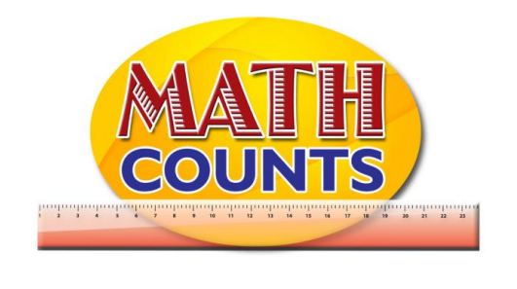

Resource Document
FOR GRADE ONE TEACHERS

Objective: Represent numbers by strokes/bundles
Topic: Atom Game and 1, 2, 3 Bundles
Atom Game
This game is called The Atom Game. Children run around the gym in all sorts of directions. The teacher calls out "Atom" and a number. Whichever number is called, the children have to get into groups of that number. For example, the teacher calls "Atom 6!" and children get into groups of 6. Those left out of a group will stand by themselves as singles.

_________________________________________________________________________________________

1, 2, 3 Bundles
- Have students sit in pairs and given a pile of cards (teacher created) with random numbers. Eg. 15, 25, 20, 36, 12, 10, 9, etc. Cards are to be placed face down.
- Player 1 will ask Player 2, “1, 2, 3 fast or slow?
- Depending on the response, player 1 will count from 1 to 10 repeatedly either fast or slow until player 2 stops him/her.
- Player 1 will state the number that he/she was when he/she was stopped.
- The number that was stated will be used as the “Bundles Number”. They are to create bundles of this number.
- Each player will draw a card from the pile. Each player will work out how many bundles of the “Bundles Number” can be had from their number and how many singles.
- The player with the least (or most, if teacher so desires) wins that round.

Objective: Read and write numerals 20 -100
Topic: for “Number hunt”

These may be placed at various points for students to search for. There should be one for each multiple of ten from 20 to 100.
Instructions
Find the bundles that match the number of items in each box.
Write the number below the box.
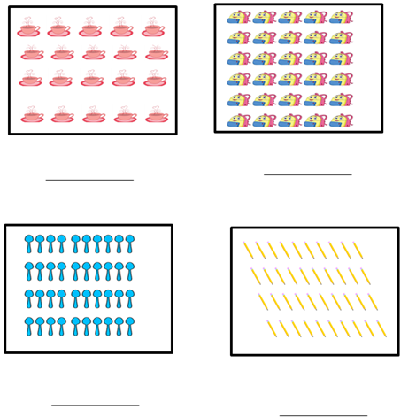
Objective: Read and write numerals 20 -100
Topic: for “Number hunt”
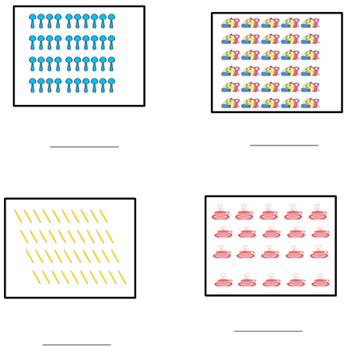
Objective: Read and write numerals 20 -100
Topic: Number Hunt Sample Pic

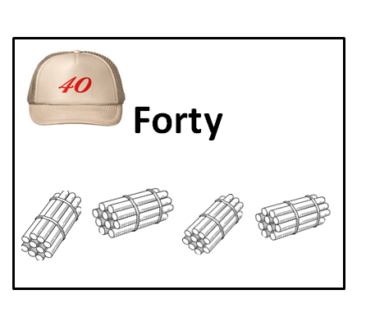

Objective: Read and write numerals 20 -100
Topic: Hundred Chart (with missing numbers)

Instruction: Teacher will call the numbers that the students are to write and they will place them in the correct place on the hundred chart.
7
19
23
35
44
58
66
71
100

