NATIONAL MATHEMATICS PROGRAMME

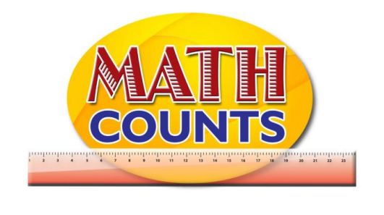

Resource Document
FOR GRADE ONE TEACHERS

Objectives:
- Know ‘one more than’ facts.
- Know ‘one less than’ fact

Topic: Go Fishing

This activity is a fishing game which is used to teach students “One More, One Less” of numbers up to 10. The game can be extended to teach students the concept beyond 10.
Resources Needed: Magnet on a string, paper clips, number cards (placed in order from 1-10), paper fishes,
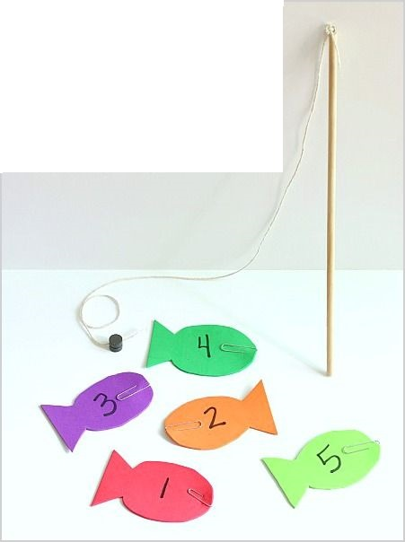
Activity
- Put ten fish shapes on the table with paper clips on the nose of each fish. Tell the students, ‘Today we are going to play a fishing game and you will be learning about numbers that are one more or one less.’
- Let the child catch a fish with the magnet and put it alongside the number 1 on the number track. Ask students the following questions.

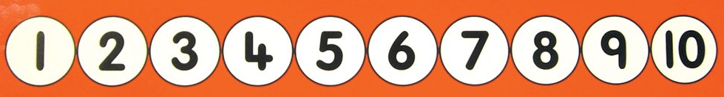
Figure 1: Number Track
How many fish have you caught?
If you catch another fish, how many fish will you have?
What is one more than one?

- ‘Catch another fish.’ Ask students the following questions.
How many fish will you have then?
Let’s catch another fish. How many will we have then?
If the child counts from one each time, continue with this activity but you will need to repeat this
kind of counting activity in different contexts, for example putting apples in a bowl or jumping
along a floor number track, emphasising one more and one less. You need to be clear that: ‘You
don’t need to count from one each time. We knew there were three fish, so one more makes four.’
?
- If the child predicts wrongly, catch another fish and count the number of fish to check the answer.
Ensure that you say ‘One more than one is two’, and so on, and that the child repeats this.
- Catch another fish.’
NB. You can demonstrate the meaning of ‘one less’ in a similar way. You could put ten fishes on a piece of blue paper for the pond, and mark the number track with a paper clip starting at 10.
Count the fishes with the child and then let them catch one.
How many fish are left in the pond?
What is one less than ten?
Let the child move the paper clip on the number track to one less than ten.

Objectives:
- Know ‘one more than’ facts.
- Know ‘one less than’ fact

Topic: One More, One Less Bingo

This assessment activity is a variation of a Bingo Game. The objective of the game is to determine whether or not students can identify one more and one less than numbers 1-9.
Resources: Bingo Cards, Spinners (with numbers 1-9 for one less and 0-9 for one more)
Instructions:
- Students will be supplied with Bingo cards containing numbers between 1 and 10.

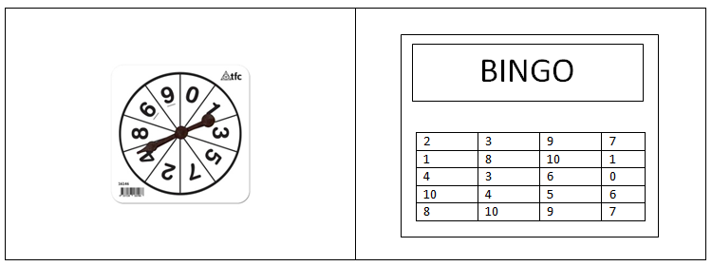

- Teacher will spin the spinner and call out the number. Students will cross out the number of their card that is one more (or one less) than the number called.
- The first student to get four numbers crossed out in a row wins the game.

Objectives:
- Recognize and make ten facts

Topic: Make Ten Card Game

The objective of this game is for students to put two (or more) numbers together to make a total of ten.
Resources: One pack of playing cards
Instructions
1. You have one deck of cards, from which you remove the picture cards
2. You place three rows of three cards face up between the players and deal each player five cards. The rest of the cards are placed in a 'top up' pile between players
YOU MUST USE AT LEAST ONE CARD FROM THE SET OF 3X3 between players but the aim is to get rid of all the cards in your hand.
3. The first player has a turn to make ten (for example: the player might have a 7 in their hand and there is a 3 on the floor).
4. Each player will have what is called a “Victory Pile”. Once ten is made the cards that were used to make it are put into the players “Victory Pile” and a new one is put in the empty spot between the players from the 'top up' pile.
5. The next player has their turn and you continue until someone gets rid of all the cards in their hand.
Note: you may use more than one card from either your hand or the cards between players.
You may say pass if you cannot make 10. The teacher can check the victory piles to determine whether or not students have really grasped the concept of making ten.

Objectives:
- Memorize and recall addition facts up to the sum of ten.
- Know addition facts (commutative property).

Topic: Addition Go Fish

The aim of the game is for students to practice addition facts of sums up to ten
Resources: Number cards
Instruction
- Set sum target between 1 and 10.
- Take out any cards above that target number. For example, if the target number is 7, take out all the number cards that are 8 and above. Deal 6 cards to each player and put the rest face-down in the middle.
- Tell students that they are going to play a kind of "Go Fish", only instead of finding matching cards, they are going to be asking for cards that add up to 7 (or whatever target number was chosen). If you are holding a 5, you can ask, "Heather, do you have a 2?" If she does not, she says, "Go fish." The child then has to take a card from the deck in the middle. The game ends when one person runs out of cards.
- The winner is the person who ended first, or the one with the most pairs.
Teacher can check the pairs to determine if students really understand the concept.

