NATIONAL MATHEMATICS PROGRAMME

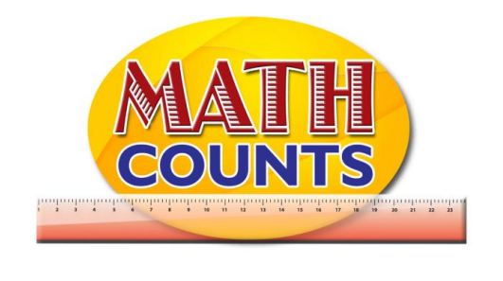

Resource Document
FOR GRADE ONE TEACHERS

Objective: Identify straight and curve path and associate them with longer and shorter paths
Topic: Which Path is the longest?

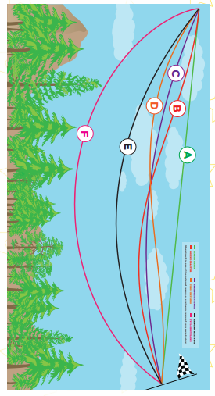
Before you check…
Which path looks the shortest? _________________________________________________
Which path look the longest? _________________________________
Which paths look about the same? ______________________________________

After you measure…
Positions | Paths
1st
2nd
3rd
4th
5th
6th

Objective: Identify straight and curve path and associate them with longer and shorter paths
Topic: Path Experiment Instruction (outside experiment)

Paul walked from point A to point B by going through the building. What type of path did he take? Was it Straight or Curve?

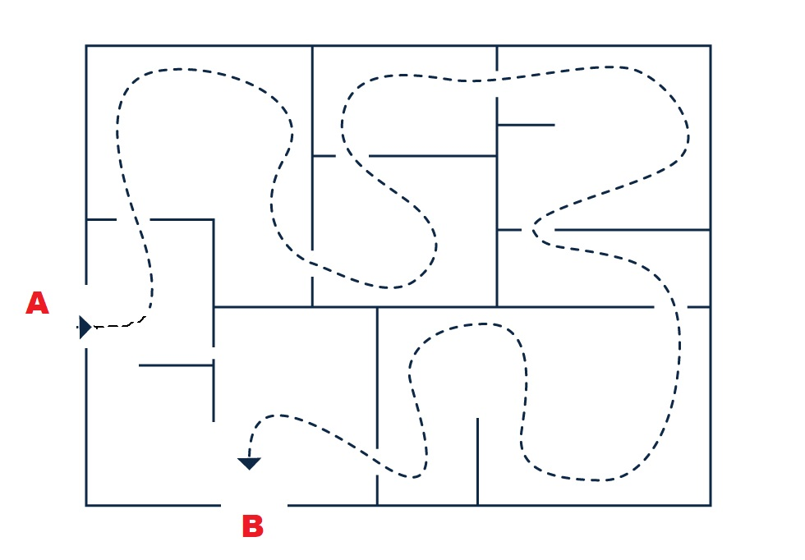

Your Task:
Take the same path as Paul, but use straight lines only. Start at point A and end at point B.
How did you make straight lines? Did you have any problems following Paul’s path?