NATIONAL MATHEMATICS PROGRAMME

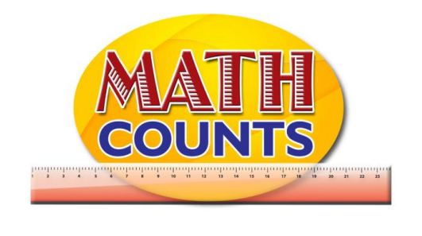

Resource Document
FOR GRADE ONE TEACHERS

Objective: Identify measurable attributes of objects. A box has dimensions (length, width, height), weight, volume (non-standard)
Topic: Exploring Attribute Worksheet
Provide students each group with four items (mix of heavy and light, small and large). Use suggested items.
Rocks, golf balls, and wooden blocks, as well as large but relatively light items such as beach balls, balloons, and large paper bags.
_________________________________________________________________________________________________
Have children compare the weight of the items.
Arrange Items from lightest to heavy

VERY LIGHT |  |  |  |  | VERY HEAVY
Beach ball |  |  |  |  | Rock

________________________________________________________________________________________________
Have them line up the items from smallest to largest and then from lightest to heaviest.
Arrange Items from smallest to largest

SMALL |  |  |  |  | LARGE
Rock |  |  |  |  | Beach Ball
(Guide them to see that larger items do not necessarily weigh more than smaller items.)
Conclusion: What did you notice? What did you find out?
________________________________________________________________________________________
________________________________________________________________________________________
________________________________________________________________________________________
Objective: Identify objects of equal/unequal length
Topic: Equal or Unequal? - Sample Table

Strings of Equal Length
Set | # of paper clips long | Number of strings in set | Colors of strings in set
1 | 5 paper clips long | 7 | 2 red  3 blue  2 yellow
2 | 7 paper clips long | 9 | 5 red  1 blue  1 yellow
3 | 8 paper clips long | 5 | 1 red  4 blue  2 yellow

Strings of un-Equal Length
COLOUR | 5 Paper clips long | 7 Paper clips long | 8 Paper clips long
RED | 2 | 5 | 1
BLUE | 3 | 1 | 2
YELLOW | 2 | 1 | 2

Objective: Identify objects of equal/unequal length
Topic: Estimation Table

OBJECT | ESTIMATED LENGTH | ACTUAL LENGTH | COMMENTS
Book | About 2 hand span | 3 hand spans

Objective: Identify objects of equal/unequal length
Topic: Estimation Table – Which is longer?

LINE | ESTIMATED LENGTH | ACTUAL LENGTH | COMMENTS

Conclusions: (What did you use to measure each line? Which lines did you think were of the same length? Did anyone else get the same measure as you by using their hand or foot span? What ideas can you conclude from this exercise?)

