NATIONAL MATHEMATICS PROGRAMME

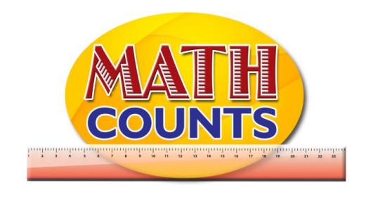

RESOURCE DOCUMENT
FOR GRADE ONE TEACHERS

Objective: Collect, sort and group data using attributes closely related to students to classify data
Topic: Sample Chart - Favourite Shape
Provide a chart listing of shapes and have students go to the board to place a sticker beneath their favourite shape.
Sample Chart - Favourite Shape
Circle | Triangle | Square | Rectangle

Objective: Collect, sort and group data using attributes closely related to students to classify data
Topic: Survey Questions for data collection

Organize students in groups (depending on the size of your class and resources available) and give each group a survey question along with the simple material they will use to represent data on a pictograph. They will question each other and use simple materials to collect and organize the data.
Suggested simple materials are clothes pins, ribbons or strings, sticky notes or strips of coloured paper, linking cubes, coloured links, elastic bands, large paper clips, fudge sticks, plastic cups or empty tins.
Each group will collect, sort, group and present the data to the class.

Suggested survey questions:

- What is your favourite colour?

- What is your favourite pet?

- What is your favourite flavour ice-cream?

- What is the colour of your shoes?

- How many people are in your family?

Topic: Survey Questions for data collection
Sample Representations
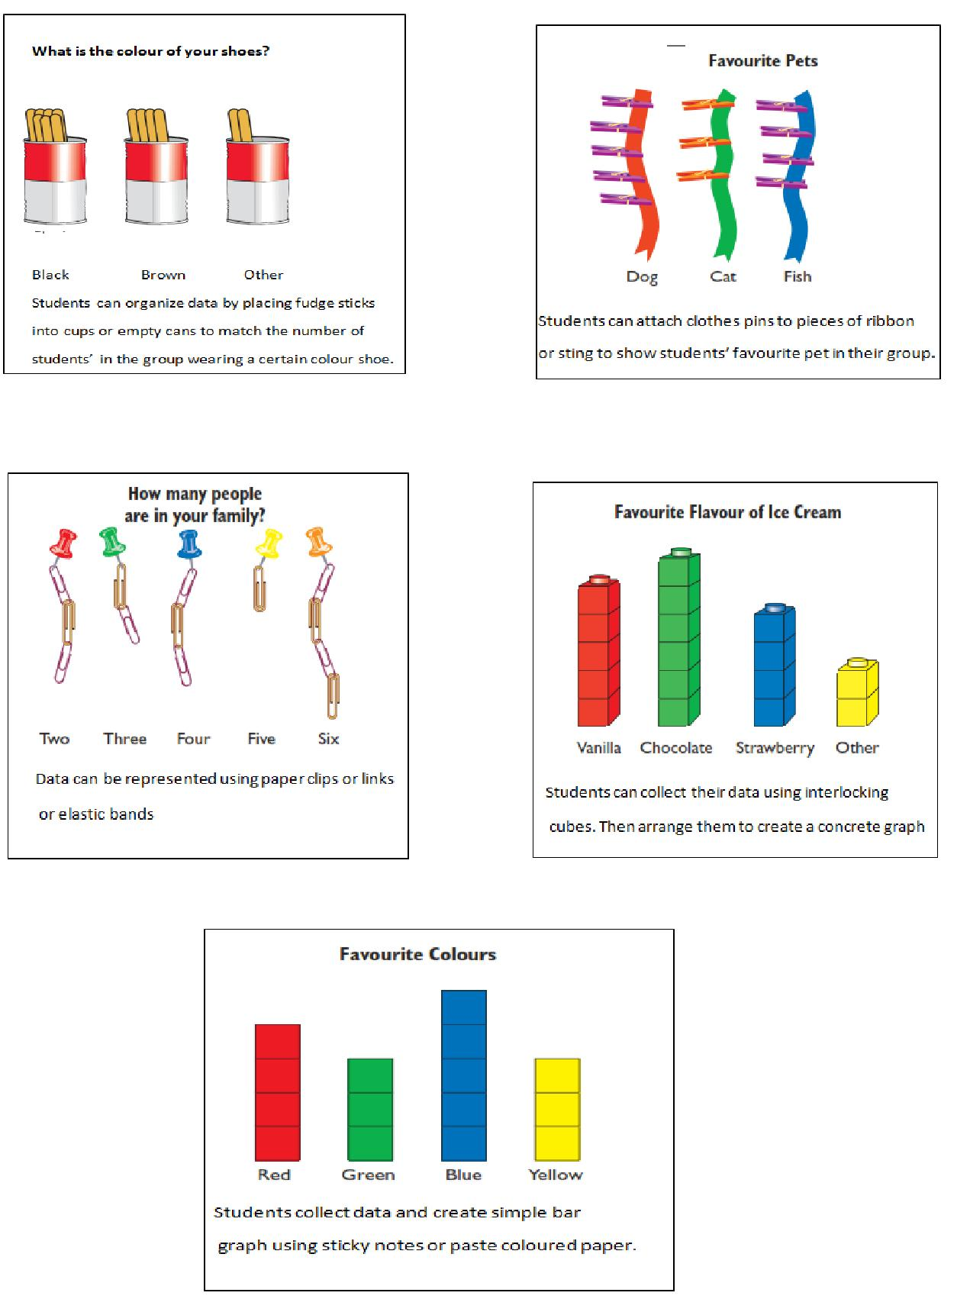

Topic: The pictograph shows the birth months of children in Grade 1 Red
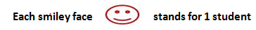
January
February

March

April

May

June

July

August

September

October

November

December

Topic: Activity sheet- Animals on the Farm

Name: ___________________________ Date: __________________________________

Look at the picture of the animals on the farm. Count how many of each type of animal there are, then colour the number of bars to match each type of animal on the bar graph below.
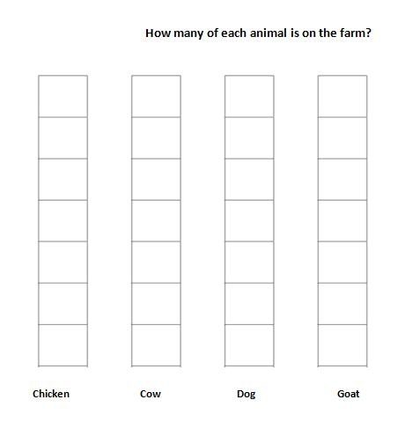

Animals on the farm
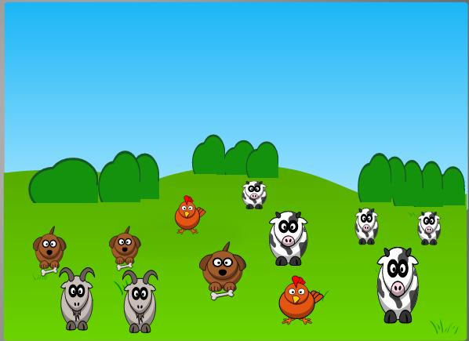
Topic: Candies pictograph

Name: ______________________________ Class: ___________________

The following pictograph shows the number of candies I got from Monday to Friday. Answer the questions.
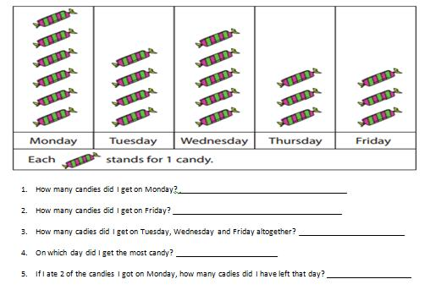

- How many candies did I get on Monday? _____________________

- How many candies did I get on Friday? ___________________

- How many candies did I get on Tuesday, Wednesday and Friday altogether? ____________

- On which day did I get the most candy? _____________________

- If I ate 2 of the candies I got on Monday, how many candies did I have left that day?

