NATIONAL MATHEMATICS PROGRAMME

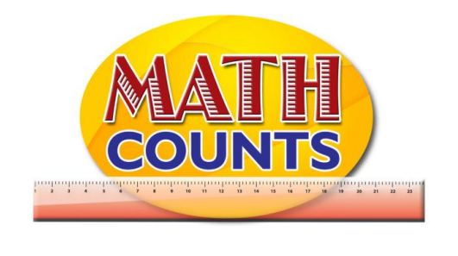

RESOURCE DOCUMENT
FOR GRADE ONE TEACHERS

Objective: Identify and name geometric shapes observed in the environment (circle, rectangle, square, triangle).
Topic: Shape Cards

Who am I ? | Who am I ? | Who am I ?
Who am I ? | Who am I ? | Who am I ?

Objective: Identify and name geometric shapes observed in the environment (circle, rectangle, square, triangle).
Topic: Shape Hunt Recording Sheet
Find objects in the classroom with parts that looks like each of the shape in the recording sheet. Draw a picture of the each object in the space beside the matching shape.
Shapes | What did you find?
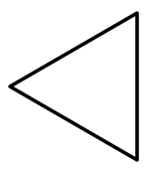

Objective: Identify and name geometric shapes observed in the environment (circle, rectangle, square, triangle).
Topic: Make an Object

Cut out the shapes. Glue one or more shape to a sheet of paper to make pictures of objects.

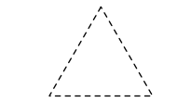
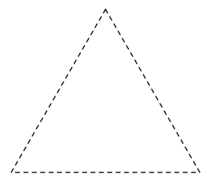

SAMPLE OBJECTS

NATIONAL MATHEMATICS PROGRAMME

RESOURCE DOCUMENT
FOR GRADE ONE TEACHERS

Provide a chart listing of shapes and have students go to the board to place a sticker beneath their favourite shape.

Favourite Shape
Circle | Triangle | Square | Rectangle

Survey Questions

Organize students in groups (depending on the size of your class and resources available) and give each group a survey question along with the simple material they will use. They will question each other and use simple materials to collect and organize the data. Suggested simple materials are clothes pins, ribbons or strings, sticky notes or strips of coloured paper, linking cubes, coloured links, elastic bands, large paper clips, fudge sticks, plastic cups or empty tins. Each group will collect, sort, group and present the data to the class.

Suggested survey questions:

- What is your favourite colour?

- What is your favourite pet?

- What is your favourite flavour ice-cream?

- What is the colour of your shoes?

- How many people are in your family?

Sample Representations
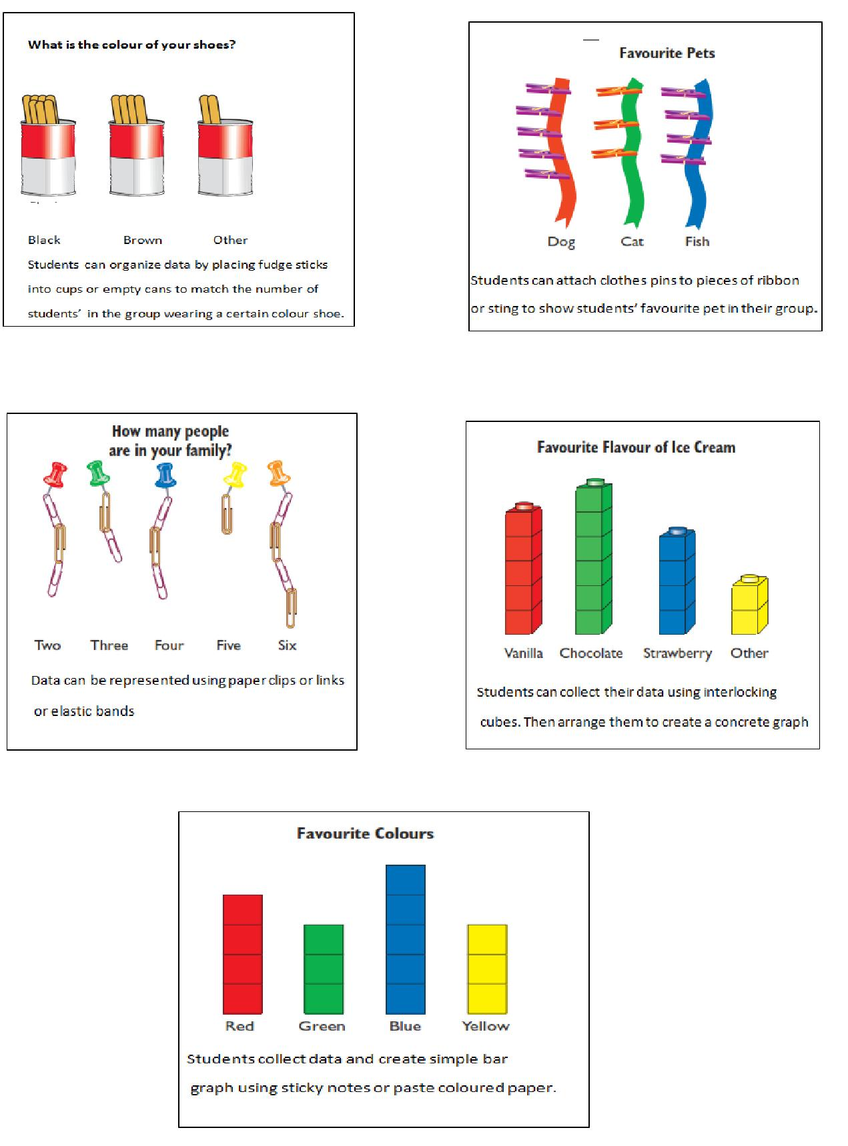
The pictograph shows the birth months of children in Grade 1 Red
Birthdays
January
February

March

April

May

June

July

August

September

October

November

December

Activity sheet- Animals on the Farm

Name: _________________________________

Date: __________________________________

Look at the picture of the animals on the farm. Count how many of each type of animal there are, then colour the number of bars to match each type of animal on the bar graph below.
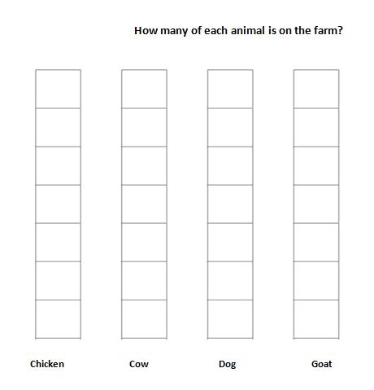
Animals on the farm
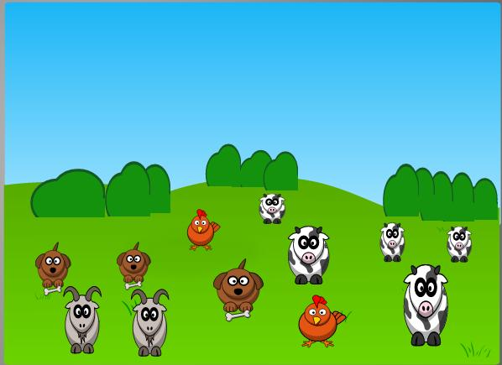
Candies pictograph
Name: ______________________________ Class: ___________________

The following pictograph shows the number of candies I got from Monday to Friday. Answer the questions.
