NATIONAL MATHEMATICS PROGRAMME

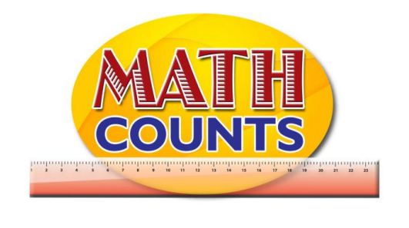

Resource Document
FOR GRADE ONE TEACHERS

Objective: Identify geometric shapes in natural and man-made objects
Topic/Title: Geometry Matching Game

GEOMETRY MATCHING GAME (and resources for Concentration Game)

Apple

Tree
Dog | 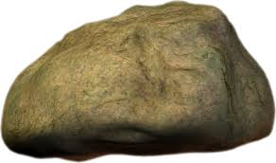
Rock | 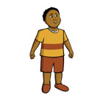
Boy

Girl
Sun | 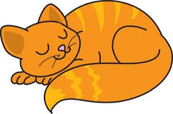
Cat
Pineapple
Star | 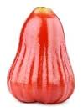

SAMPLE CARDS FOR “CONCENTRATION” GAME
Tree

Dog
Rock
Boy
Girl

Sun
Cat
Pineapple
Star
Apple

