NATIONAL MATHEMATICS PROGRAMME

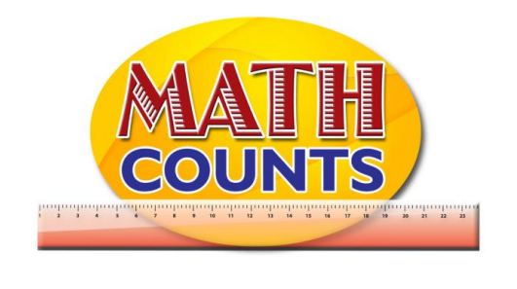

**RESOURCE DOCUMENT**

FOR GRADE ONE TEACHERS

Objective: Describe simple fraction using words

1. Identify halves of a whole
2. Identify quarters of a whole

**Story “Give Me Half” by Stuart J. Murphy**

|  |  |
| --- | --- |
|  |  |
|  |  |
|  |  |
|  |  |
|  |  |
|  |  |
|  |  |
|  |  |
|  |  |
|  |  |
|  |  |
|  |  |
|  |  |
|  |  |
|  |  |

Objective: Identify halves of a set of objects

Topic: Half-Whole Mat

|  |  |
| --- | --- |
| **WHOLE**  **1** | |
| **HALF $$\frac{1}{2}$$** | **HALF $$\frac{1}{2}$$** |

Objective: b. Identify quarter of a set of objects

Topic: Half-Whole Mat

|  |  |  |  |
| --- | --- | --- | --- |
| **WHOLE** | | | |
| **QUARTER** | **QUARTER** | **QUARTER** | **QUARTER** |