NATIONAL MATHEMATICS PROGRAMME

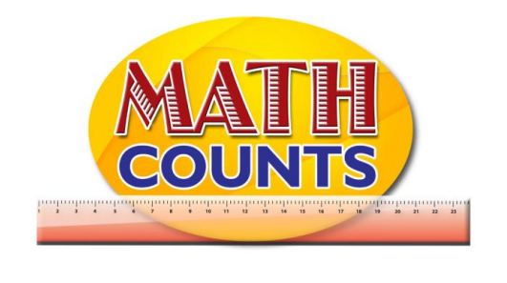

RESOURCE DOCUMENT
FOR GRADE ONE TEACHERS

Objective: Identify counting and whole numbers
Topic: Poem- One, Two, Buckle My Shoe

One, two,
Buckle my shoe;
Three, four,
Shut the door;
Five, six,
Pick up sticks;
Seven eight, Lay them straight;
Nine, ten, A good fat hen;

Objective: Know the doubling facts
Topic: Doubling Facts worksheet

First Set | Draw another set | How many do you now have? | What do you notice?
 |  |  | The first set doubled
2 | 2 | 4
3
5
6

Objective: Know the doubling facts
Topic: Sample Number Cards
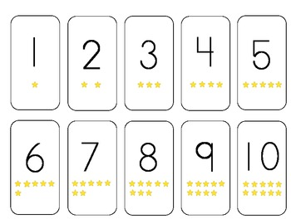

Objective: Know the doubling facts
Topic: Slides and Ladders – Adding Doubles

Roll a die and move the corresponding number of spaces on the game board. Find the sum of the double. If the answer is correct, remain - but if it is incorrect, move back to the former position. 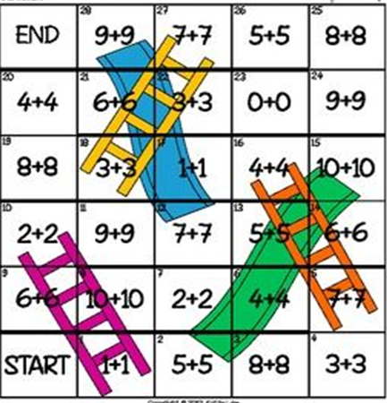

Objective: Know the doubling facts
Topic: Count by 2 to at least 20

Count by 2 to at least 20- Hundred Chart
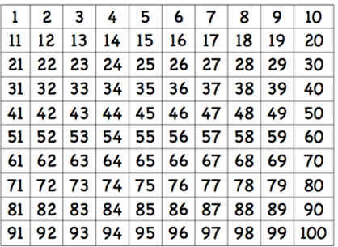

Objective: Know the doubling facts
Topic: Domino Doubles Game
Domino Card Mat
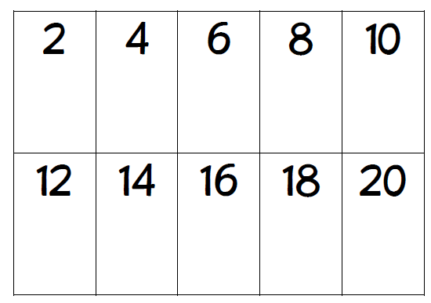

Doubles Dominoes
 |  | 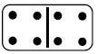 | 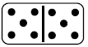
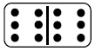 | 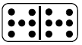 | 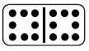 | 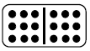

Objective: Count by 2 to at least 20
Topic: Scenarios

- Mark thinks that if he continues counting by 2s, he will say the number 21.  14, 16, 18…  Do you agree? Explain why. | - John thinks that if he continues counting by 2s he will say the number 16.  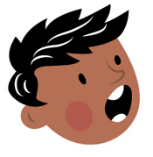  8, 10, 12…  Do you agree? Explain why.
- Paul thinks that if he continues counting by 2s, he will say the number 10.  2, 4, 6…  Do you agree? Explain why. | - Ricky thinks that if she continues counting by 2s, she will say the number 29.  22, 24, 26…  Do you agree? Explain why.

