NATIONAL MATHEMATICS PROGRAMME

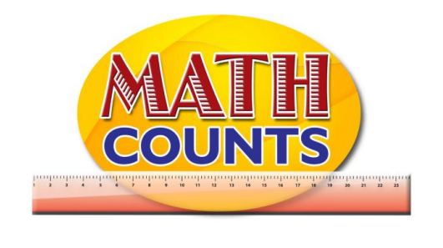

Resource Document
FOR GRADE ONE TEACHERS

Objective: Compare and order objects by their linear measurements using the same non-standard units
Topic: Which Object Measures…
Which object?  (Draw item here) | Measures
 | I am 3 pencils long
 | I am 5 pencils long
 | I am 7 pencils long
 | I am 9 pencils long

Draw the items in order according to their lengths.
Item 1 | Item 2 | Item 3 | Item 4

Conclusions:

Objective: Compare and order objects by their linear measurements using the same non-standard units
Topic: Guess My Measure

RULES
Select two students to come to the front of the room.

Student 1: Selects an object to measure and a non-standard unit (of their choice) that the object should be measured with.
For example, Object: bag strap;
Non-standard unit: a string the length of an eraser, or paper clips.

Student 2: Guess how many of the non-standard unit would measure the object.
The teacher records ‘student 2’ response on the board.

Both students will then do the actual measuring to see how close the guess was. Have students interchange roles after each round.

The student who comes the closer to the estimate gains a point.

