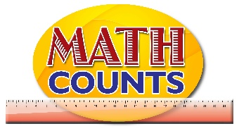
National Mathematics Team
Grade 1 – Planning Sessions Template

Topics/Objectives | Main Concept | Teaching/Learning Activities | Assessment/Homework Activities
- Use any simple shape to make patterns by repetition (e.g. ink blobbing, tessellation, potato-printing). | - Pattern  - Shape | Activity One  Provide students with water paint (can be placed in small jar covers) then distribute to each student a tool for blobbing (sponge or halved potato) and have them cover any given page with their tool.  After dipping their tool (sponge or potato) in the paint, guide students to use the shapes to create recognizable patterns. Allow students to describe their patterns to the class.  Activity Two- Repetition  Provide students with a set of shapes (or any other appropriate item) to form patterns.  Begin with a single repeat.  Guided Questions  Look at this pattern, what do you notice? Based on what you are seeing here, which shape would come next? If we were to extend our pattern to the left, which shape could we place at the front so that the pattern remains the same? Why?  Move on to double repeat  Guided Questions  How is this image different from the first one? Do you think it is still a pattern? If we wanted to extend this pattern, what would come next?  ICT inclusion  Activity One  Teacher will display patterning app on the board and display the patterns, teacher will be able to ask students to guess the next item: http://www.mathlearningcenter.org/web-apps/pattern-shapes/  Activity Two  Use the website below to get students to figure out which shape comes next in a pattern. http://more2.starfall.com/m/math/geometry-content/load.htm?f&n=geo-maze&y=1&d=demo | Activity One  Have students create their own Pattern Worksheet with Answers for their classmates to try.  ICT Inclusion  Have students practice extending patterns by engaging in the following games:  https://www.education.com/game/roly-pattern-quiz/  Extension  https://www.education.com/game/patterns-quiz/

