REVISED OCTOBER 03, 2018
Contents
WHAT IS THE PRIMARY EXIT PROFILE? 3
The Purpose of PEP 3
DEVELOPMENT OF 21ST CENTURY SKILLS 4
CRITICAL THINKING 4
CREATIVITY 4
COMMUNICATION 4
COLLABORATION 4
WHAT ARE THE COMPONENTS OF PEP? 5
CURRICULUM BASED 5
ABILITY TEST 5
PERFORMANCE TASK 5
PRIMARY EXIT PROFILE – ABOUT THE TEST 6
Table 1: National Standards Curriculum coverage 7
ADIMINISTRATION OF DIFFERENT COMPONENTS 9
HOW WILL PEP BE IMPLEMENTED? 10
PRIMARY EXIT PROFILE 2019-REGISTRATION PEP6 10
DIRECTIVES FOR COMPLETING THE REGISTRATION FORM 11
SPECIAL ACCOMMODATION FOR CHILDREN SITTING NATIONAL EXAMINATIONS 13
PEP6 Examination Grid 15
PEP 2019 – SAMPLE REGISTRATION FORM 16
LIST OF RECEIVING SCHOOLS 17
PRIMARY EXIT PROFILE - PLACEMENT RULES 18

WHAT IS THE PRIMARY EXIT PROFILE?

The Primary Exit Profile (PEP) will replace the Grade Six Achievement Test. The assessment instruments are designed to ascertain student’s performance through demonstration of 21st Century Skills aligned to the National Standards Curriculum (NSC) and will provide an account of the academic profile of each student. The PEP will require students to demonstrate their competencies by applying knowledge and skills with emphasis on students’ higher order thinking skills such as problem solving, analysis and synthesis.

The Purpose of PEP
- It will be used to generate a credible profile of each student
- It will provide accurate information about students’ knowledge, abilities, and skills across several subject areas
- It will provide evidence of students’ readiness for grade 7.
- It will function as a means of placing students in secondary schools, and will inform the kind of approach that will be required for their success at the secondary level.

- Some benefits of the new approach to the assessment are –
- More claims will be made about students.
- Students’ achievement of the curriculum and their progress will be monitored more regularly.
- More opportunities will be provided for teachers to identify students’ strengths and weaknesses and therefore plan lessons to meet the specific needs of students, and to enhance their strengths.
- Enhance the relationship between assessment and curriculum as well as school – home/community relationship.
- Students can monitor their own learning

DEVELOPMENT OF 21ST CENTURY SKILLS

CRITICAL THINKING
Critical thinking involves solving complex issues and problems by analyzing and interpreting information to make informed judgements and decisions.

CREATIVITY
Creativity and innovation involves the ability to turn ideas into action to meet the needs of the society, on a selected context. It also involves:
- thinking outside the box
- experimenting with new techniques, materials, strategies or perspectives

COMMUNICATION
Communication involves the ability to articulate or explain ideas clearly for an audience. This may be done orally or in written form.

COLLABORATION
Collaboration involves working together in teams by capitalizing on each other’s strength to accomplish a common goal.

True mastery of any subject involves a student being able to apply subject content, skills and abilities in different ways to solve a problem.
Mastery = Subject Content + Skills

WHAT ARE THE COMPONENTS OF PEP?

PEP comprises three components that will be used to generate each student’s profile. This profile will help in determining the pathway for students as they transition to the secondary level and allow for targeted learning based on their individual needs.
CURRICULUM BASED TEST
CURRICULUM BASED TEST
- Subjects to be assessed are Mathematics, Language Arts, Science and Social Studies.
- Will assess content based on the objectives in the NSC at grade 6.
- Will consist of selected-response items and constructed-response questions.

ABILITY TEST

- Will assess students’ aptitude in areas of numeracy and abstract thinking.
- Requires students to read analytically and demonstrate quantitative reasoning skills.
- NOT based on curriculum but on the general mental ability
- Will be administered in Grade 6

PERFORMANCE TASK

PERFORMANCE TASK
- A performance task is an activity or assessment that asks students to solve a problem by demonstrating their knowledge, understanding and proficiency
- Performance Tasks use real world scenarios
- It will require students to apply a variety of skills to complete the task; not just recall of information
- Will be curriculum based and assess students’ grasp of concepts, principles and procedures coming from Mathematics, Science, Language Arts, and Social Studies
- Performance Tasks will be prepared by the MoEYI and sent to schools
- It will be administered once in grade 4, once in grade 5 and once in grade 6.
- It will be administered by the teacher within the student’s classroom

PRIMARY EXIT PROFILE – ABOUT THE TEST

The Primary Exit Profile uses an evidence-centered design (ECD) and applies Webb’s depth of knowledge (DoK) model in sampling students’ capabilities.
An important feature of an ECD assessment is that students may be partially credited for work leading up to a final response even if the final response is not entirely accurate. The PEP will make use of this feature through the inclusion of a variety of item types specially designed to give students the opportunity to demonstrate their capabilities.

The depth of knowledge approach utilizes a process and criteria for analyzing the alignment between objectives and assessment tasks. This model places tasks into categories that reflect the different levels of cognitive expectations (thinking) required to complete each task. There are four DOK levels:
Figure 1.
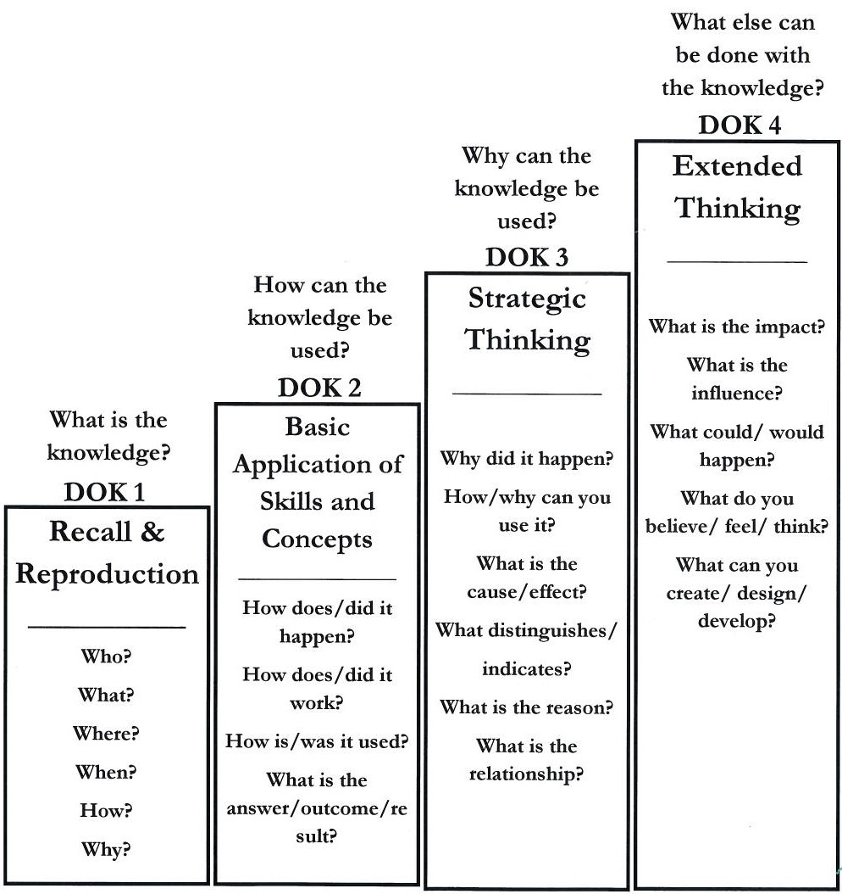
http://inservice.ascd.org/what-exactly-is-depth-of-knowledge-hint-its-not-a-wheel/
The Performance Tasks component will comprise items at the highest DOK level (DOK-4). This component will require students to navigate through a task that takes them successively through the range of thinking required from the lower levels. These will place students in situations where they need to take action over an extended period and with tasks that culminate in addressing a single problem situation.
The Curriculum Based Test (CBT) component of PEP will comprise items that may span between the DOK levels 1 to 3. At the lowest level, students may be asked to reproduce facts or simple procedures. DOK Level 2 requires engagement of mental processing beyond recalling or reproducing a response. That is, students will take the simple facts (from DOK-1) and further process them to illustrate knowledge that was not directly taught. At the DOK level 3 students are expected to make short-term use of higher order thinking processes, such as analysis and evaluation, to solve real-world problems with predictable outcomes. Stating one’s reasoning is a key marker of tasks that fall into this particular category.

Table 1: National Standards Curriculum coverage

Subject | Curriculum Objectives Tested
Language Arts | PERFORMANCE TASK  Grammar & Conventions, Comprehension, Vocabulary  Writing, Research/Study Skills  (Terms 1 and 2)  CURRICULUM BASED TEST  Terms 1 and 2 ALL UNITS  Grammar & Conventions, Comprehension,  Vocabulary, Research/Study Skills
Mathematics | PERFORMANCE TASK  Number, Measurement and Geometry (Terms 1 and 2)  CURRICULUM BASED TEST  Terms 1 and 2 ALL UNITS  Number , Measurement , Geometry ,Data Handling, Statistics, Probability and Algebra
Social Studies | CURRICULUM BASED TEST  Roots of Caribbean culture and identity: the Chinese and East Indians  (Term 1, Unit 1)  Independence and nationhood (Term 1, Unit 2)  Showing honour and respect for our country (Term 1, Unit 3)  Mountains (Unit 1, Term 2)  Landmasses (Term 1, Term 2)  Leadership and Governance (Term 2, Unit 3)
Science | CURRICULUM BASED TEST  The Environment (Term 1, Unit 1)  Energy: Light & Sound (Term 1, Unit 2)  Materials: Properties & Uses (Term 2, Unit 1)  Human Body Systems (Term 2, Unit 2)  Mixtures (Term 2, Unit 3)
Ability Test | Covers information not beyond grade 3  Basic reading and quantitative reasoning

N.B. The PEP is NOT the end of primary school instruction. Grade 6 Curriculum MUST therefore be completed during the rest of the school year to ensure that students are adequately prepared for Grade 7. This means that the students should be exposed to Term 3 component of the NSC.
Format of the PEP Components
Components | Subjects | Number of Items | Item Types
Performance Tasks | Mathematics | 4 – 6 | Selected response and Constructed response items
 | Language Arts | 4 – 6 | Selected response and Constructed response items
Curriculum Based Test | Mathematics | 40 | Selected response and Constructed response items
 | Social Studies | 40 | Selected response and Constructed response items
 | Science | 40 | Selected response and Constructed response items
 | Language Arts | 40 | Selected response and Constructed response items
Ability Test |  | 40 | Multiple Choice items

ADMINISTRATION OF DIFFERENT COMPONENTS
PERFORMANCE TASK

Grade | Subjects that will be assessed
6 | - Mathematics  - Language Arts
5 | - Mathematics  - Language Arts  - Science  - Social Studies
4 | - Mathematics  - Language Arts

Grade | Performance Task | Ability Test | Curriculum Based Test
6
5
4
At which grade levels will the various components of PEP be administered?

Grade 6 Components | Schedule
Performance Task  (Mathematics and Language Arts) | March 27 and 28, 2019
Ability Test | February 26, 2019
Curriculum Based Test (Mathematics, Language Arts, Science and Social Studies | April 16 and 17, 2019
At what time of year will the Grade 6 Components be administered?

HOW WILL PEP BE IMPLEMENTED?

PEP will be implemented on a phased basis, in an effort to ensure that ALL students are adequately prepared for the first administration. The examination will be implemented in the following ways:
- Students who are currently in Grade 6 will be the first PEP cohort. They will do only the Grade 6 components in 2019
- Students who are currently in Grade 5 will do their Grade 5 Performance Task in 2019 and in 2020 they will do the Grade 6 components.
- Students who are currently in Grade 4 will be the first cohort that will have a complete profile generate, they will do:
  - Grade 4 PT in 2019
  - Grade 5 PT in 2020
  - and ALL grade 6 components (PT, CBT and AT) in 2021

How will Placement in Secondary School be affected?
- The placement mechanism will remain the same with students having seven (7) school choices.
- The first 5 choices will be any school of choice across the island. The 6th and 7th choices must be made from the cluster list of schools.
- The assessment results will also be made available as is customary during the third week of June.

PRIMARY EXIT PROFILE 2019-REGISTRATION PEP6

Primary Exit Profile registration starts in September of each year. Principals are expected to collect the following:
- Individual candidate’s Registration Form (Pre-slugged)
- School’s list (Broad sheet) (Pre-slugged)
- Blank School’s list
- Blank Registration Forms (Individual)
- Cluster list for their school

DIRECTIVES FOR COMPLETING THE REGISTRATION FORM

Attention All Principals
Please note the following eligibility requirements for sitting PEP6:
- Mastery of the Grade 4 Literacy and Numeracy Test. This is in keeping with the Competence Based Transition Policy. Students who do not master will sit the grade six component but will be identified on one of the three pathways under the Alternative Pathway for Secondary Education (APSE). Those on pathway two and three will do the psychoeducational assessment for us to be able to determine the type of intervention to best suit their needs at secondary
  - Eligibility based on age:
- Students who were born between January 01, 2006 and
December 31, 2008, (both dates inclusive) are eligible to sit PEP.
- Students born in 2005 and were granted special permission to sit in 2018 are eligible to sit PEP
N.B. Students born after December 31, 2008 will NOT be allowed to sit the PEP Examination in 2019.
ALL eligible students MUST be registered for PEP 2019.
- Students who were born in the year 2006 MUST sit PEP in 2019. Principals are encouraged to check all Grade 4 to 6 classes to ensure that all students eligible to sit are registered.

- Each school should receive from SAU a candidate’s list of their students who have been registered to sit, as well as pre-slugged individual registration forms.

- Schools are asked to examine the candidate’s list and ensure that ALL their eligible students are listed. Any eligible candidate not listed should be added and a blank registration sheet be filled out for the student with his/her correct information. A CERTIFIED COPY OF THE BIRTH CERTIFICATE MUST BE ATTACHED TO THE FORM OF ALL NEW STUDENTS.

- The candidate’s list must also be used to verify the information.
For example:
- addition of student’s middle name
- correction of and addition of date of birth
- correction of name ( spelling, deed-poll) Deed-poll is to be submitted
- correction to gender.
N.B. A birth certificate must be attached ONLy TO NEW STUDENTS AND STUDENTS WHOSE NAME/D.O.B. NEED CORRECTION.
- Comments should be placed on the list to indicate the status of the students, for example:
- Transferred out (Give the name of the school if known)
- Migrated
- Repeater and/or deferral etc. (Repeaters are those in Grade 5, and deferred or those who are of age and requesting permission to sit in 2019)
- Transferred in (Give the name of the school if known)

- Deferral of Candidates:
- The candidate’s birth certificate and a letter requesting deferral MUST be attached to the registration form for the candidate to be qualified for deferral.
- Students are allowed to defer any component of the PEP at Grade 6.

- PEP Entry Forms should be signed by parent/guardian in every
instance, if possible (The forms should not be withheld by the schools
if they are not signed by the parents/guardians. However, please bear in mind that the Ministry of Education, Youth and Information will not take responsibility for choices written on the forms without parents’/guardians’ consent).

- School Choices
Principals are reminded to examine selected choices for candidates ensuring that:
- Choices are not repeated
- Choices are selected from specified cluster list sent to the school.

- Students who have passed the eligible age to sit PEP, but were granted deferrals in 2018 due to special circumstances must provide the evidence (usually applies to students
with special accommodation needs). A letter approving such would have been sent to the school in the previous year.

- Students requiring Special Accommodation (such as extra time, a prompter, writer, large print etc.) for 2019 sitting should provide documentation by DECEMBER 31, 2018. (e.g. medical reports, psycho-educational assessment reports)

- Schools which need additional entry forms may photocopy blank forms for use. Ensure that the forms selected are those for the current year as there maybe changes to the school choices. Forms already printed with another student’s information must NOT be reproduced.

- BLANK FORMS MUST BE COMPLETED AND SUBMITTED FOR ALL NEW STUDENTS INCLUDING ‘TRANSFERS IN’ AS WELL AS FOR ADDITIONAL STUDENTS. THOSE STUDENTS WHO ARE COMING FROM OVERSEAS KINDLY INDICATE COUNTRY AND NATIVE LANGUAGE

- ALL UNUSED FORMS MUST BE RETURNED WITH THE COMPLETED FORMS

- TO IMPROVE OUR PROCESSES THE STUDENT ASSESSMENT UNIT WILL NOT BE ACCEPTING NEW REGISTRANTS AFTER JANUARY 31, 2019

Queries For All Examinations Administered Must Be Done Within Six (6) Months Of The Candidates Sitting The Examination.

SPECIAL ACCOMMODATION FOR CHILDREN SITTING NATIONAL EXAMINATIONS

Please note that students sitting the Primary Exit Profile Assessment (PEP), at any grade, MAY receive examination accommodations under specific conditions:
- Students with special education needs/disabilities
  - Students with documented special education needs may be granted accommodations as is supported by their psycho-educational or medical report.
- Students whose native language is not English
  - Special examination accommodation may also be granted to students whose first language is not English, if the student is not proficient enough in the use of the English Language. Schools should indicate during the registration process, what language the student is competent in and that they would require an interpreter for the examination. Parents would be asked to assist in supporting this process/intervention.
- Students who have a medical condition
  - Students who have a medical condition that may inhibit their performance in the examination may receive accommodations. This includes students with chronic medical conditions, students who are hospitalized or who might have had an accident close to the examination period which will affect them sitting the examinations. This includes a student who may have suffered a broken arm and may not be able to write, in this case a writer may be provided.

Procedures for Requesting Special Accommodations
In order for a candidate to benefit from special examination accommodations, the following procedures should be followed:
- A written request must be made the Student Assessment Unit of the Ministry of Education, Youth and Information (MoEYI), detailing the nature of the exceptionality and the specific needs of the candidate.
- All requests for accommodations MUST be accompanied by a formal Psycho-educational/behavioural assessment, or a medical report, based on an assessment conducted in the last two years, from an authorized individual or agency, such as the Mico CARE Centre.
- If the Ministry is not satisfied with the adequacy of a report, clarification may be sought and additional information requested.
- Requests may be made by a school, parent or a professional treating the child for a particular condition, such as a medical doctor or a psychologist.
- Request should ideally be made at least twelve weeks prior to the sitting of the examination, or in accordance with established examination, application/registration procedures.
- A review of the request will be done by a team in the Special Education Unit in the Ministry and the recommendations forwarded to the Student Assessment Unit.
- The Student Assessment Unit will then send a written response concerning the status of the application, to the institution/organization, or individual making the request.
- The accommodation being requested should be consistent with accommodations used by the student in the classroom. That is, students should be accustomed to using the particular accommodations during classroom instruction and internal examinations.
 | Allocation of time for students to be granted extra time for PEP
Components | Subjects | Actual Time | Extra Time
Performance Tasks | Mathematics | 2hr | 30 mins
 | Language Arts | 2hr | 30 mins
Curriculum Based Tests | Mathematics | 1hr. 30mins | 20 mins.
 | Social Studies | 1hr. 30mins | 20 mins.
 | Science | 1hr. 30mins | 20 mins.
 | Language Arts | 1hr. 30mins | 20 mins.
Ability Test |  | 1hr. 30mins | 20 mins.

PEP6 Examination Grid

The PEP6 examination grid is to be used in identifying the student’s year of birth that correspond with the current sitting year.
DATE OF BIRTH REQUIREMENT FOR PRIMARY EXIT PROFILE – PEP6
CALENDAR YEAR
 | 2019 | 2020 | 2021 | 2022 | 2023 | 2024 | 2025 | 2026 | 2027
2006 | √
2007  YEAR OF BIRTH | √ | √
2008 | √ | √ | √
2009 |  | √ | √ | √
2010 |  |  | √ | √ | √
2011 |  |  |  | √ | √ | √
2012 |  |  |  |  | √ | √ | √
2013 |  |  |  |  |  | √ | √ | √
2014 |  |  |  |  |  |  | √ | √ | √
2015 |  |  |  |  |  |  |  | √ | √
2016 |  |  |  |  |  |  |  |  | √

These are the relevant Years of Birth for students sitting the PEP6
Please note - STUDENTS ARE ELIGIBLE TO SIT THE PEP6 ONLY ONCE.
All students born 2006 MUST be registered to sit PEP 6 in 2019.
Copyright © S.A.U.

PEP 2019 – SAMPLE REGISTRATION FORM
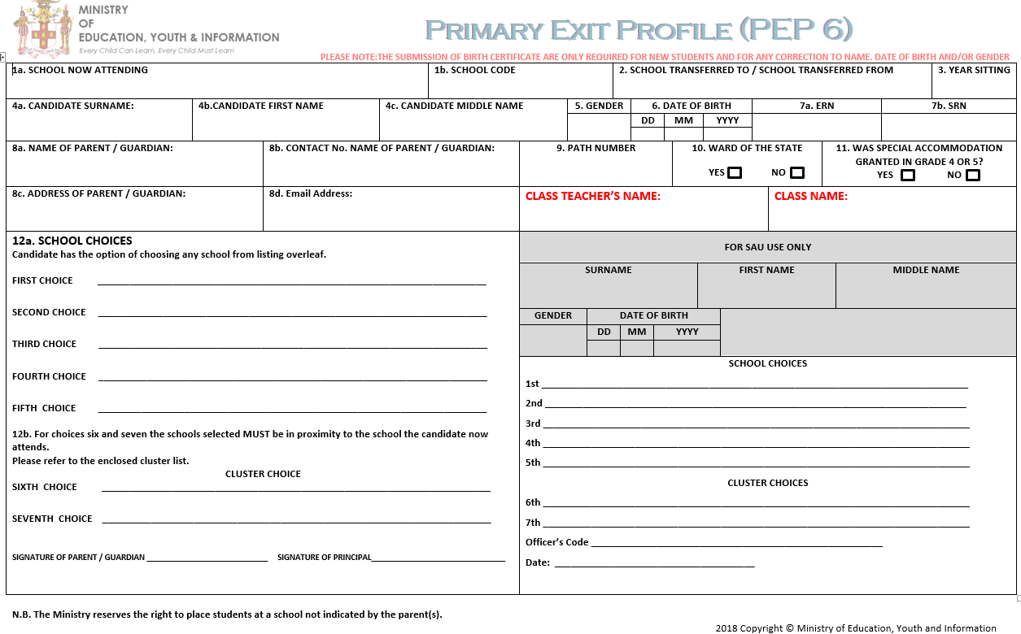

REGION 1  Kingston  St. Andrew | ALPHA ACADEMY (GIRLS ONLY) | HAILE SELASSIE HIGH | OBERLIN HIGH | WOLMER'S GIRLS’ HIGH
 | ARDENNE HIGH | HOLY CHILDHOOD HIGH (GIRLS ONLY) | PAPINE HIGH | MICO PRACTISING. PJH
 | CALABAR HIGH (BOYS ONLY) | HOLY TRINITY HIGH | PEMBROKE HALL HIGH | STONY HILL PJH
 | CAMPERDOWN HIGH | IMMACULATE CONCEPTION HIGH (GIRLS ONLY) | PENWOOD HIGH
 | CAMPION COLLEGE | JAMAICA COLLEGE (BOYS ONLY) | ST. ANDREW HIGH (GIRLS ONLY)
 | CHARLIE SMITH HIGH | KINGSTON COLLEGE (BOYS ONLY) | ST. ANDREW TECHNICAL
 | CLAN CARTHY HIGH | KINGSTON HIGH | ST. GEORGE'S COLLEGE (BOYS ONLY)
 | DENHAM TOWN HIGH | KINGSTON TECHNICAL | ST.HUGH'S HIGH (GIRLS ONLY)
 | DONALD QUARRIE HIGH | MAVIS BANK HIGH | TARRANT HIGH
 | DUNOON TECHNICAL | MEADOWBROOK HIGH | THE QUEENS SCHOOL (GIRLS ONLY)
 | EDITH DALTON JAMES HIGH | MERL GROVE HIGH (GIRLS ONLY) | TIVOLI GARDENS HIGH
 | EXCELSIOR HIGH | MONA HIGH | VAUXHALL HIGH
 | GAYNSTEAD HIGH | NORMAN MANLEY HIGH | WOLMER'S BOYS’ HIGH
REGION 2  St. Thomas  Portland  St. Mary | ANNOTTO BAY HIGH | HORACE CLARKE HIGH Formerly Islington High | SEAFORTH HIGH
 | BRIMMERVALE VALE HIGH | MARYMOUNT HIGH (GIRLS ONLY) | ST. MARY HIGH
 | BUFF BAY HIGH | MORANT BAY HIGH | ST. MARY TECHNICAL
 | CARRON HALL HIGH | ORACABESSA HIGH | ST. THOMAS TECHNICAL
 | FAIR PROSPECT HIGH | PAUL BOGLE HIGH | TACKY HIGH
 | HAPPY GROVE HIGH | PORT ANTONIO HIGH | TITCHFIELD HIGH
 | IONA HIGH | ROBERT LIGHTBOURNE HIGH | YALLAHS HIGH
REGION 3  St. Ann  Trelawny | AABUTHNOTT GALLIMORE HIGH | HOLLAND HIGH | STEER TOWN ACADEMY | BELLEVUE PJH
 | ALBERT TOWN HIGH | MARCUS GARVEY TECHNICAL | TROY HIGH
 | BROWN'S TOWN HIGH | MUSCHETT HIGH | WESTWOOD HIGH (GIRLS ONLY)
 | CEDRIC TITUS HIGH | OCHO RIOS HIGH | WILLIAM KNIBB HIGH
 | FERNCOURT HIGH | ST. HILDA'S HIGH (GIRLS ONLY) | YORK CASTLE HIGH
REGION 4  St. James  Westmoreland  Hanover | ANCHOVY HIGH | GREEN ISLAND HIGH | MALDON HIGH | RHODES HALL HIGH
 | BELMONT ACADEMY | GREEN POND HIGH | MANNINGS HIGH | RUSEA'S HIGH
 | CAMBRIDGE HIGH | HERBERT MORRISON TECHNICAL | MAUD MCLEOD HIGH | SPOT VALLEY HIGH
 | CORNWALL COLLEGE (BOYS ONLY) | HOPEWELL HIGH | MERLENE OTTEY HIGH | ST. JAMES HIGH
 | FROME TECHNICAL | IRWIN HIGH | MONTEGO BAY HIGH (GIRLS ONLY)
 | GODFREY STEWART HIGH | KNOCKALVA TECHNICAL | MT. ALVERNIA HIGH (GIRLS ONLY)
 | GRANGE HILL HIGH | LITTLE LONDON HIGH | PETERSFIELD HIGH
REGION 5  St. Elizabeth  Manchester | ABERDEEN HIGH | DE CARTERET COLLEGE | MAY DAY HIGH | WINSTON JONES HIGH
 | B.B. COKE HIGH | HAMPTON HIGH (GIRLS ONLY) | MT. ST. JOSEPH CATHOLIC HIGH | NAIN PJH
 | ROGER CLARKE HIGH Formerly Balaclava High | HOLMWOOD TECH. HIGH | MILE GULLY HIGH | NEW FOREST PJH
 | BELLEFIELD HIGH | LACOVIA HIGH | MUNRO COLLEGE (BOYS ONLY)
 | BISHOP GIBSON HIGH (GIRLS ONLY) | LEWISVILLE HIGH | NEWELL HIGH
 | BLACK RIVER HIGH | MAGGOTTY HIGH | PORUS HIGH
 | CHRISTIANA HIGH | MANCHESTER BELAIR HIGH | ST. ELIZABETH TECHNICAL
 | CROSS KEYS HIGH | MANCHESTER HIGH | SYDNEY PAGON HIGH
REGION 6  Clarendon  St. Catherine | ALSTON HIGH | DENBIGH HIGH | GUY'S HILL HIGH | SPANISH TOWN HIGH
 | ASCOT HIGH | DINTHILL TECHNICAL | INNSWOOD HIGH | ST. CATHERINE HIGH
 | BOG WALK HIGH | EBONY GROVE ACADEMY | JONATHAN GRANT HIGH | ST. JAGO HIGH
 | BRIDGEPORT HIGH | EDWIN ALLEN HIGH | JOSE’ MARTI TECHNICAL | ST. MARY'S COLLEGE
 | BUSTAMANTE HIGH | ELTHAM HIGH | KELLITS HIGH | TACIUS GOLDING HIGH
 | CEDAR GROVE ACADEMY | EWARTON HIGH | KEMPS HILL HIGH | THOMPSON TOWN HIGH
 | CENTRAL HIGH | FOGA ROAD HIGH | KNOX COLLEGE | VERE TECHNICAL
 | CHARLEMONT HIGH | GARVEY MACEO HIGH | LENNON HIGH | WATERFORD HIGH
 | CLARENDON COLLEGE | GLENMUIR HIGH | MCGRATH HIGH
 | CLAUDE MCKAY HIGH | GLENGOFFE HIGH | OLD HARBOUR HIGH
 | CUMBERLAND HIGH | GREATER PORTMORE HIGH | SPALDING HIGH

LIST OF RECEIVING SCHOOLS
List of receiving schools

PRIMARY EXIT PROFILE - PLACEMENT RULES

The Placement Process
Currently, candidates have five school choices (preferences) selected from any (island-wide) public secondary level institutions accepting Grade 7 students (High, Technical and a few Primary and Junior High receiving schools).
After the tests are administrated each subject is scored and an overall composite score is computed. This composite score is then ordered for ranking each student in order of performance. The student with the highest overall composite score will be ranked 1; computerized placement will then commence and candidates are placed in schools by rank order; highest first.
Preference Placement: Candidate preferences are checked in turn, starting with the first preference through to the fifth, to determine if the candidate can be placed in any of their selected schools. Checks are done for gender match and available space. Each receiving school indicates the number of candidates which it can accept (available space). Candidates are placed until there are no more spaces available, in other words, until the school is full.
Cluster Placement: if all five (5) preferences are exhausted, then the student is placed based on their two (2) cluster choices.
Secondary Placement/Proximity Placement: If the candidate cannot be placed in any of his or her preferences or by Cluster choices, the placement programme automatically goes to the Ministry’s Secondary Placement (Proximity) List. This List identifies receiving schools into which candidates attending a particular primary level school can be placed if they do not obtain a space in one of their preferences. Once again based on space availability.
Manual Placement: If based on their rank and preferences, no space is assigned, then that candidate is placed on a list to be manually placed by the Ministry’s regional representatives.

