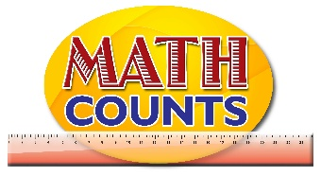
National Mathematics Team
Grade 1 – Planning Sessions Template

Topics/Objectives | Main Concept | Teaching/Learning Activities | Assessment/Homework Activities
- Use Ordinal numbers up to the 10th.  - Write number words 0-19.  - Write numerals 0-19.  - Associate number with numerals. | - Order  - Sets  - Number  - Numeral  - Digit | - Use Ordinal numbers up to the 10th  Engage students in everyday activities that require the use of ordinal numbers: running a race, position in the line on entering the class, names in the register, months of the year and days of the week (use the actual date and explore the position of that month or day using a Calendar) and so on. See Resource document page 4 for a sample worksheet that can be adapted to any of the above activities.  Allow students to count objects to observe stable order principle.  ICT inclusion  - Allow students to play the game on the website cited below which requires them to find the ordinal positions of objects. https://www.turtlediary.com/game/ordinal-numbers.html  - Write number words and numerals 0-19.  Create a Numeral Mat with numbers 0-19 written in words. The Numeral Mat can be a laminated sheet of paper with the names of numbers (in desired shapes). Create Number Chips – these can be cardboards (or laminated paper) – each having a numeral from 0 to 19 on one of its sides.  Have students use the chips to cover the corresponding numerals on the Numeral mat.  - Activity - Exploring Numbers  Have students explore numerals using worksheets similar to that on page 6 of the Resource document. Here students look at number names, symbols and represent them as parts of a whole and as dots on the Ten Frame  - Use the idea of subitizing (telling the number of objects at a glance) to determine the number of objects given.  Example:  6 hearts | - Use Ordinal numbers up to the 10th  See Resource document pages 2 and 3 for Story Sequencing Activities that utilizes Ordinal numbers.  - Give students paper cutouts with the pictorial representations of numbers (see Resource document page 5). The cards will be in no particular order. They will be required to write the numeral on the back of each card. They will then be required to order the cards from 0-10. Students may be asked to order the cards in their own way (while maintaining the stable order principle.)  ICT Inclusion  Students will use app to choose the appropriate numbers in order  http://www.softschools.com/math/ordering_numbers/  Ordinals: Number train activity for students to choose the appropriate numbers to be placed in the train in the correct order.  http://www.softschools.com/counting/games/number_train/  - Write number words and numerals 0-19.  Students will play the game ‘I Have Who Has’. (See page 7 of the Resource Document)  - ICT inclusion  Students will work independently to match numbers to words using the website below:  http://www.sheppardsoftware.com/mathgames/earlymath/fruitShootNumbersWords.htm
- Identify set with 20 through 100 members  - Join two sets (up to 10 members) using mathematics sentences  - Use +, -, and = correctly to complete mathematical sentences. | - Number  - Numeral  - Digit  - Join  - Sum | - Join two sets (up to 10 members) using mathematics sentences  Give students two sets of counters and have them draw set diagrams representing the sum.  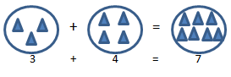  Example:  - Have students draw set diagrams to represent simple mathematical sentences given. For example, 10 + 9 = 19 or 15 - 6 = 9  Students will be able to use the app to choose sets that add up to ten(10) members:  https://www.mathgames.com/skill/1.43-choose-addition-pictures-up-to-10  Identify set with 20 through 100 members  Introduce students to the Ten Frame (See pages 8 to 11 of the Resource document for blank and populated template and also for a sample Ten Frame Bingo game). To reinforce the identification of numbers on a Ten Frame have students play the Ten Frame Bingo game.  Lead students to identify a populated frame as having 10 elements. Introduce an additional frame with one element. Increase the elements in the second frame by one until the frame is filled thus producing two frames with a total of 20 elements.  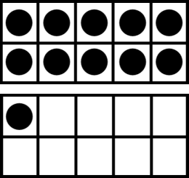  Have students work in groups to produce various sets using their Ten Frames.  - Have students engage in the Number Recognition Game (See page 12 of the Resource Document). Students will listen as the teacher calls out the numbers and will identify the number on their cards. The student who finds most or all of the numbers wins.  - Use +, -, and = correctly to complete mathematical sentences.  Have students engage in the One more One Less task. Give them a number card, Ten Frames and counters. Challenge them to represent the number (on the number cards) using their Ten Frame and counters. Then have students use their resources to populate the template on page 13 of the Resource document with one more and one less than that same number. | - Use +, -, and = correctly to complete mathematical sentences  Provide students with printed cut out images of the four basic operations. A chart for whole group or worksheets for small groups could be provided with incomplete sentences as shown below.  2 2 = 4  Students will determine the correct operation and will demonstrate their thinking by inserting the correct operation in the space provided.  Join two sets (up to 10 members) using mathematics sentences  - Give students the opportunity to determine addends for a given sum.  Example:  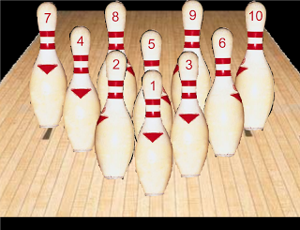  Each bottle has the number of marbles as written on the bottle. Anna wants to get a total of 8 marbles. Which 2 bottles should she hit?  ICT Inclusion  Addition: Students will be shown activity of addition to choose the sum, activity also lends itself to other areas such as multiplication http://www.softschools.com/math/games/addition_games/  - Identify set with 20 through 100 members  Have students play Ten Frame bingo games. See sample card on page 10 Of the Resource document. Link to the entire set is below.  https://docs.google.com/viewer?a=v&pid=sites&srcid=ZGVmYXVsdGRvbWFpbnx3YXRlcnNraW5kZXJnYXJ0ZW5maWxlc3xneDoyOTRjZmFiNmQxMTE4ZWNk  Extension to Ten Frame task  Have students fill in the blank numbers on the Hundred chart (See page 10 of the Resource document) and represent each number found using their Ten Frames.

