Grade 5
 | Topics/Objectives | Main Concepts | Teaching Learning | Assessment/Homework Activities
 | - Estimate, measure and record distances including the perimeter of polygons in millimetres and/or centimetres and metres.  - Solve problems requiring the calculation of one of the following:  i). The perimeter.  ii). Length of one side.  iii). The number of sides of a regular polygon, given the other two measures.  - Develop the relationship between units of length and units of area.  - Find the area of polygons by counting squares. | Millimetres  Polygons  Centimetres  Metres  Perimeter  Regular polygon  Irregular polygon  Area  Length  Unit | Allow students to estimate, measure and record the length of sides for polygons in groups. Calculate the perimeter of these polygons. Extend activity to things in the classroom and school environment that have the shape of a polygon or have polygon faces. Guide students in recording information in millimetres, centimetres and metres in a given table. (SEE Resource Document, Page 1)  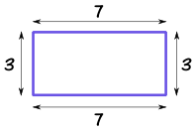  Allow students to explore real life situations that requires them to calculate the perimeter of polygons. Extend situations to cases where students have to find the missing lengths of one side and the number of sides of a regular polygon, given the other two measures using their previous knowledge of properties of polygons. (See Resource document, Page 2-3)  e.g.  1. A rectangular garden has a fencing of 24 m. What are the possible dimensions of the garden in cm/ m?  - Incorporate the use of manipulative such as square tiles, Cuisenaire rods to create samples of shapes with possible dimensions reflecting the stated perimeter. (See perimeter in example stated above)  Allow students to use interlocking cubes to make a shape of their choice. Have students trace the shape on plain paper. They should record the lengths for the sides of the shape. They will then count the squares on one face the shape they created and record its area.  Example  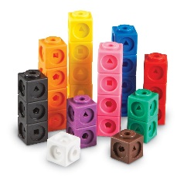  Guide students in using a ruler to draw polygons of their choices on grid paper (See resource document for sample grid, page 6). Have them counting squares and using rounding principle to count square more or less than half. See example below.  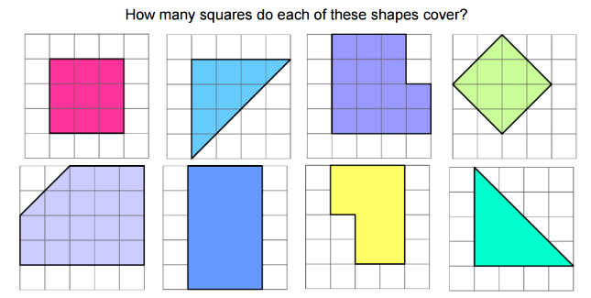 | Have students answer questions where they are required to use estimation skills to assist in finding perimeter of objects in millimetres, centimetres and metres.  Eg.  1. Draw objects or shapes of things in the environment that you thinks could have a possible perimeter of:  - 6m  - 100cm  - 250mm  NB. Write in possible lengths of sides.  Allow students to work in groups to estimate and calculate the actual distances/ locations and perimeter of different shapes. (See resource Doc Page 3-4, Activity 2.)  Home work:  Allow students to research polygons in real life on the internet. Have them create a model of one of these things highlighting the actual perimeter that they should have in the most appropriate unit. Eg. netball court, cricket pitch, stop sign etc…  Count squares in order  to find area of irregular  shapes. See Resource  Document, page 2
 | - Differentiate between the use of the square centimetre, the square metre and the hectare in measurement situations  - Compute the measurement of the area of rectangular regions using the square centimetre or square metre as unit.  - Investigate then determine the largest/ smallest perimeter that can be obtained given a specified area.  - Solve problems based on computing the measurement of the area of a rectangular region. | Hectare  Centimetre  Metre  Square  Unit  Area  Rectangular  Perimeter | Guide students in a discussion, as to the appropriate unit of measurement given various measurement situations. Example: Area of the screen of a laptop/monitor (square centimetres). Area of the classroom (square metres) and Area of a plot of land (hectares).  Give students situations and allow them to use square tiles in groups to model for the best outcome as it relates to finding largest/smallest possible perimeter that can be obtained given a specified area  Example:  RADA has promised a farmer a plot of land measure 24 square metres.  - Use square tiles to design a possible shapes that the land could have.  - What is the largest possible perimeter that can be obtained from this area?  - What is the smallest possible perimeter that can be obtained from this area?  - Make recommendations to this farmer as to the best shape to use if the purpose of the land is rare either animals or plant crops.  Students will be shown a diagram of a tiled  rectangular hallway. Allow students to count the number of square tiles that make up area of the hallway. Have students derive a formula for finding the area of the hallway.  Example:  9  9  9  3 rows of 9 square units  3 X 9 = 27 square units  Use ruler to measure length and width of rectangular objects in their classroom. Allow students to find the area of these shapes using the derived formula.  Give students the following scenario: A cricket pitch was prepared for an upcoming match. It is to be protected from rain and other elements. Come up with possible dimensions for a regular covering if the pitch is of length 20m and width 3m. Ensure that the area is not more than 100 square metres. Use the dimensions selected to calculate the area of the covering to be used to protect the pitch from rain and other elements. | Give students the  following scenario:  - Mr. Brown has a  rectangular pool of  length 37m, and width  15m, that is infested with frogs and he wants to cover it. How much  mesh will he need to buy in order to cover the  pool?  - Have students’ complete activity.  Guide students in playing game with a pair of dice. They will use the numbers obtained on the dice as lengths of side for rectangular regions. They will create a house floor plan on a grid by drawing rectangular regions on their grid to represent different parts of the house. The person with the largest area and perimeter on their floor plan wins. (See resource document for example).  Have students create rectangular regions on grids in Microsoft word application based on given area.

