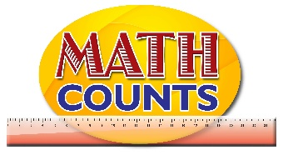
National Mathematics Team
Grade 1 – Planning Sessions Template

Topics/Objectives | Main Concept | Teaching/Learning Activities | Assessment/Homework Activities
Identify straight and curve path and associate them with longer and shorter paths. | Straight  Curve  Path  Longer  Shorter | Activity 1  - Set up at least two stations within the classroom (use a sign to indicate each station – Station A, Station B and so on). Create paths to each station using paper tape – decide where the paths will begin. You could begin all paths at the classroom door.  - Have students work in pairs or threes and estimate the length of each path (using an appropriate non-standard measure). Then have them use strings (or other appropriate measures) to measure the path and record their findings.  - Have each group present their estimates and measures to the class.  Activity 2  - Provide students with the scenario on page 3 of the Resource document. Have them work in pairs to trace the path that Paul took and to identify the type of path that he took – curved.  - Challenge each student to take the same path using straight paths only. Have them discuss how they accomplish this task and the challenges that they experienced as they drew the paths. | Assessment 1  - Provide students with the activity on page 2 Of the Resource Document.

