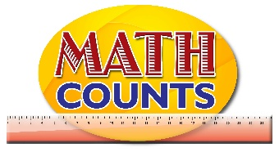

National Mathematics Team
Grade 1 – Planning Sessions Template

Strand: Statistics
Topics/Objectives | Main Concept | Teaching/Learning Activities | Assessment/Homework Activities
Collect, sort and group data using attributes closely related to students to classify data:  - Number of boys/girls  - Clothing  - Number of pencils  - Birthdays  - Height (tall or short).  Make general statements and draw conclusions based on information collected. | Table  Graph | - Provide a chart listing shapes (circle, triangle, square, and rectangle) and have students go to the board to place a sticker beside their favourite shape.  Then engage students in a discussion.  Sample questions:  How many students prefer square?  Which of the shape is liked the most……?  Why do you think ….. is the least  favoured shape?  - Organize students in groups and give each group a survey question. They will question each other using the survey question and use simple materials to organize the data collected. See resource document survey questions for further details  - Give students a blank pictograph with all or some of the months of the year on cartridge paper; this will be attached to the board. Ask students to indicate the month they were born in by raising their hands if their month is listed on the chart.  - Give each student a cut out of a smiley face and have them go to the board to paste their smiley face at their selected month. Discuss with students how to read and interpret pictographs. | 1. Have students complete activity sheet on shading bar graph to represent data from the ‘Animal Farm’. (See resource document “Animals on the farm’)  2. Give students practice worksheets on reading and analysing pictographs. See resource document (Birthday, Animals on the farm, Candies)

