Objective a.
- Write down estimates in the table below for the perimeter of the following things in the unit highlighted. Use a ruler to measure the sides and record the actual perimeter. Calculate the difference between the estimate and actual perimeter. Discuss the accuracy of your estimates.

cm

cm
mm
mm

- Complete the table below using things from your classroom or school environment.
Examples:
- Chalk/whiteboard
- Desk top
- Teacher’s table
- A chart etc……

Polygon explored | Estimate | Actual | Difference between  actual and estimate

Objective b
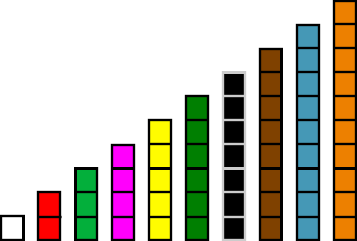
White - 1cm

Yellow- 5cm

Purple - 4cm

Light green- 3cm

Red - 2cm

Black- 7cm

Dark green - 6cm
Orange – 10cm
Blue – 9cm

Brown – 8cm

Consider that each unit represents 1cm; what is the perimeter of the shapes seen below?
- b. c.

Use combinations of the rods above to calculate different perimeters.
- Calculate the perimeter of an irregular shape that can be formed using 2 green rods, 1 red rod and 1 purple rod.

- If Peter made an irregular shape, which has a perimeter of 24cm, what is the least number of rods that he could have used?

- Draw a possible representation of Peter’s irregular shape.

- Using a 10cm rod, 4 cm rod, a 6cm rod
and a 2 cm rod
Arrange the rods in order to make:
- The smallest possible perimeter
- The largest perimeter
- Combine pieces rods to make a regular shape with an even number for its perimeter.
(Remember to show your representation for each calculated perimeter)
(While Cuisenaire rods are solids, they can be used as two dimensional objects to calculate perimeter)

ACTIVITY 2
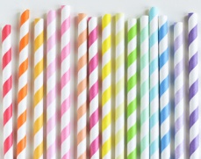
- Give students the following lengths of straw: 1cm, 2cm, 3cm, 4cm, 5cm, 6cm 7cm and 8cm which have been appropriately labeled.
- Challenge groups to use the straws to make a shape with any number of sides which has a perimeter of 11cm.

- Ask groups to choose one or more of the investigations to carry out:

- Make more than one shape with a perimeter of 11cm
ii. Try to find all the possible shapes they can make with a perimeter of 11cm
iii. Find the shortest and longest perimeter they can make using their straws.
iv. Find out which size perimeters can be made with these straws and which cannot.
(Give groups the opportunity to share their findings and engage the class in worthwhile discussion based on findings).

- Students (in groups) will be given 12 square tiles or 20 square tiles. Each should represent a rectangular area of grass on a farm. Ask students the following questions:

- What are the possible dimensions of these farms?

- Which possibility will require the most/least fencing?

- What conclusions can be drawn about the farms that required the most fencing?

Grid

Area and perimeter game
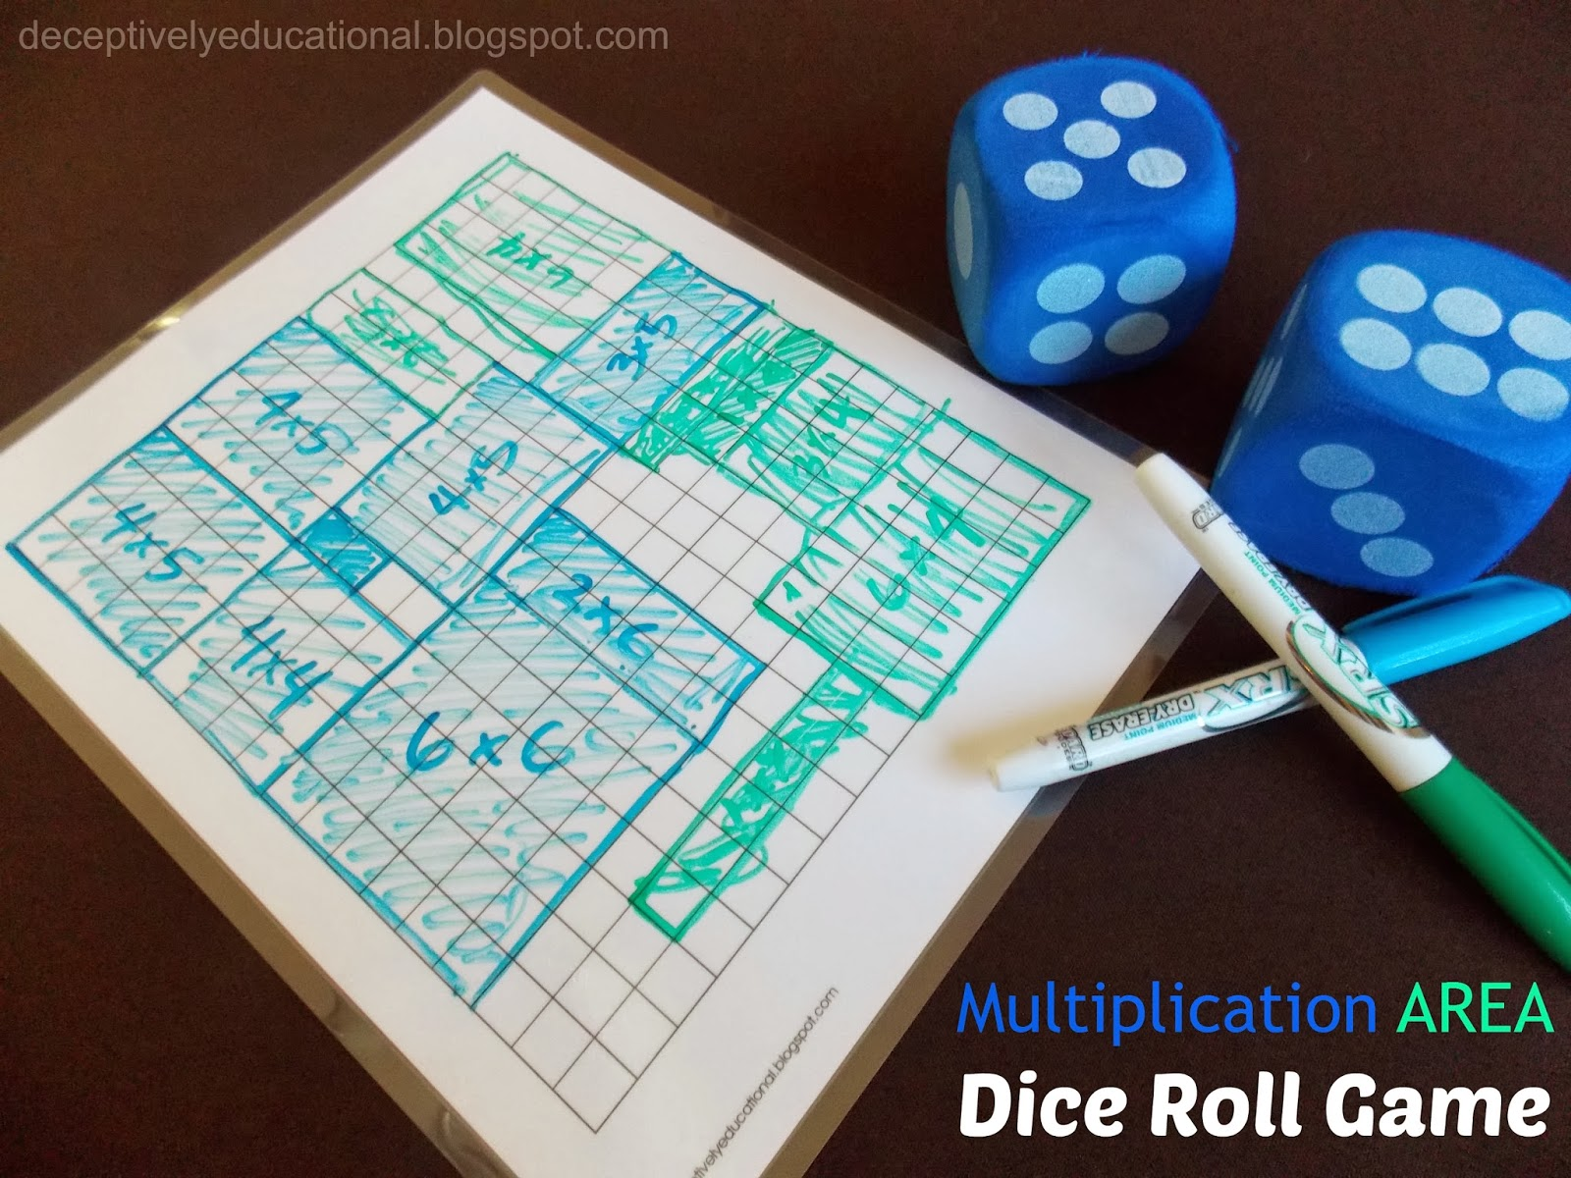

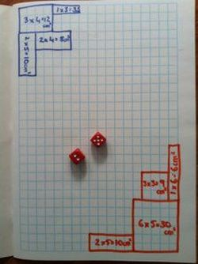

The following represents a tiled rectangular hallway with tiles

Give students graph paper or grid paper and ask
them to draw L. Example:

Have them count and record the length of each side using the units/grid. Then have them find the
perimeter.

Extension: Have students count the number of
square units within the shape and have them
record this number. Then have students say what
this represent. Repeat the activity using other
shapes, to include those which are rectangular.
Allow them to make a comparison between area
and perimeter of each shape.

