Subject: Mathematics
Content Strand: Geometry (algebra, measurement, statistics, numbers)
Grade Level: 5
Lesson Duration: 1 hour
Topic: Lines of Symmetry
Standard 1:
Explore paths, geometric shapes and space and make generalization about geometric relationships within the environment.
Attainment Target:
- Describe the relationships between and among geometric figures and explain spatial relationships.
Specific Objectives:
By the end of the lesson, pupils will be able to:
- Identify lines of symmetry from at least four pictures working in groups of five.
- Count the lines of symmetry that can be found in regular polygons.
- Use lines of symmetry to design patterns/motif to create a template for a tile, fabric or logo for a company.

SKILLS/ATTITUDES:
- Examine and label shapes
- Make generalizations
- Identify lines of symmetry
- Label lines of symmetry
- State geometric/measurement features
- Create patterns
- Write in journals
- Make pieces for Math-kit
- Work in groups
- Operate electronic devices
- Develop respect and appreciation for others’ views

Prior Learning:
Before doing this lesson, the students should already know:
- Identify the mirror line as being a line of symmetry.
- Identify the possible lines of symmetry in natural shapes.
- Identify plane shapes by names.

Instructional Materials:

- Assortment of shapes
- Pictures
- Potatoes
- Poster paint
- Blank sheets
- stencil knife
- Fruits
- Paint brushes
- Trays with water
- Activity sheets
- Mirrors (plastic)
- Journals
Technology/Electronic Resources needed:

- Multimedia project
- Tablets/ laptop/ android phone/ etc
- Accessories/ Connections - flash drive, CD, DVD, camera

Online Resources:

Line of Symmetry: http://www.mathsisfun.com/geometry/symmetry-line-plane-shapes.html

Photo grid:www.unm.edu/~jbrink/resources/Symmetry.ppt

Powerpoint: https://photo-grid.en.softonic.com/android/download

LEARNING OUTCOMES:
Students will be able to:
- Correctly identify all lines of symmetry in given shapes;
- Sort shapes according to geometric properties;
- State correctly the number of lines of symmetry in given polygons;
- Label lines of symmetry neatly and accurately;
- Innovatively design patterns using lines of symmetry;
- Make meaningful and creative Journal and Math-kit entries on each activity done on lines of symmetry;
- Actively and cooperatively participate in meaningful group discussions and activities;
- Demonstrate through ongoing reflections appreciation and respect for the views of others.

POINTS TO NOTE:
INTRODUCTION: BEAUTY OF BUTTERFLIES

The butterfly's attractiveness derives not only from colours and symmetry: deeper motives contribute to it. We would not think them so beautiful if they did not fly, or if they flew straight and briskly like bees, or if they stung, or above all if they did not enact the perturbing mystery of metamorphosis: the latter assumes in our eyes the value of a badly decoded message, a symbol or a sign. ~Primo Levi.

Have students observe projected image of butterfly as seen on whiteboard and have a class discussion.

- Symmetry is the beauty of shapes and figures.
- The idea of symmetry can be first introduced to children with examples from nature, art, and pictures of familiar objects.
- Make the connection between symmetry and its attributes in Visual Arts, Physical Education, Science and Social Studies (i.e. in patterns and designs).
- Figures can be classified according to the number of lines of symmetry in each.
- A line of symmetry separates a figure into two congruent parts such that each point in one part is reflected in the other part (this can be tested using a mirror).
- A creased line on paper is the line of symmetry/axis of symmetry or mirror line.
- Integrate across strands such as measurement (perimeter and area) of shapes as well as across subjects such as Visual Arts, Language Arts, Civics, ICT etc.

Key Vocabulary:
Symmetry (symmetrical/ non symmetrical), Polygons, reflection, mirror line, design, motif, collage, axi/axes, congruent/non - congruent, dependent, regular, irregular, characteristics/ features, lines of symmetry

Content Outline:
A line of symmetry is a line dividing a shape or object into halves such that if the shape is folded along this line both halves would match exactly. Each line of symmetry forms two congruent shapes. The number of lines of symmetry is a shape or object is dependent on the characteristics of the shape or object.
Teaching Learning Activities:

Engage
- On paper provided, allow students to put blobs of paint and then fold and squish.
- In groups of five, allow students to discuss the differences and similarities between their original pattern and the new pattern created.
- Have a whole class discussion to compare findings.
OR
- Observe a picture or a projected image of a butterfly on white board and have a class discussion.
Explore
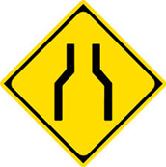
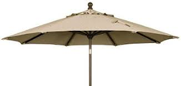

Pupils will:
- As a class, observe series of shapes in a Powerpoint (https://drive.google.com/open?id=14R4MiA7zSavx4T3Ty_ZfDvOgLSpnacM4px51-wYl7yQ) and determine the effect of lines through each.
- Examine pictures of buildings, signs and patterns on tiles, clothing, carpets, etc. to determine how engineers/designers use lines of symmetry to create balance in their designs.
- Given paper with variety of plane shapes, cut out and label (name) shapes
- Sort plane shapes and tell the criteria used when sorting.
- Fold shapes individually noting the number of lines of symmetry in each (if any)
- Share and compare results with other pairs.

Explain
- Through whole class discussion, infer why regular polygons have the same number of lines of symmetry as their sides and angles as opposed to irregular polygons.

Elaborate/Extend
- In pairs, use mirrors (plastic) to determine the symmetry of shapes cut out earlier, and then add to their Math-kits.
- participate in symmetry scavenger hunt to find objects in their classroom or school that are symmetrical.
- draw/colour/explain pictures showing how lines of symmetry can be useful in their daily lives.

Evaluate:
(Self-evaluation/Authentic Assessment)
- In Math Journals, reflect on key terms/vocabulary used throughout the learning experience (i.e. symmetry, line of symmetry, mirror line, polygons, reflection, motif, design etc.)
- WhatsApp/SnapShot reflections above as blogs to share among their peers.

ASSESSMENT

- Investigate the number of lines of symmetry in regular and irregular shapes shown below.

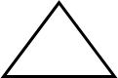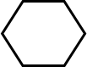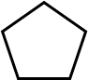

Complete table and make generalizations.

Names of Shapes  (Regular) | Number of equal sides | Number of equal angles | Number of lines of symmetry

Evaluation (Teacher):
Were students able to:
 | 0% - 50% | 51% - 80% | 81% - 100%
Identify lines of symmetry
Count the lines of symmetry in regular polygons
Use lines of symmetry to design patterns
Work collaboratively

Comments:
Areas of strengths: ______________________________________________________________________________
Areas of weaknesses ______________________________________________________________________________

Actions to be taken _____________________________________________________________________________

Extended Learning:
- Use available resources/Internet-generated devices (i.e. cellular phone, dictionary, tablet, laptop, smart phones etc.) to research what is meant by regular and irregular shapes/polygons.
- Use Photo-App https://photo-grid.en.softonic.com/android/download to manipulate polygons on an Internet-generated device to create symmetrical designs.
- Add sets of shapes made and drawn with lines of symmetry to Math-kits.
- Determine a formula for the number of lines of symmetry in a regular polygon and/or any given polygon.
- Design motif(s) to create shapes for real life products for table mats/cloths, emblems, company logos etc. using potatoes. eg
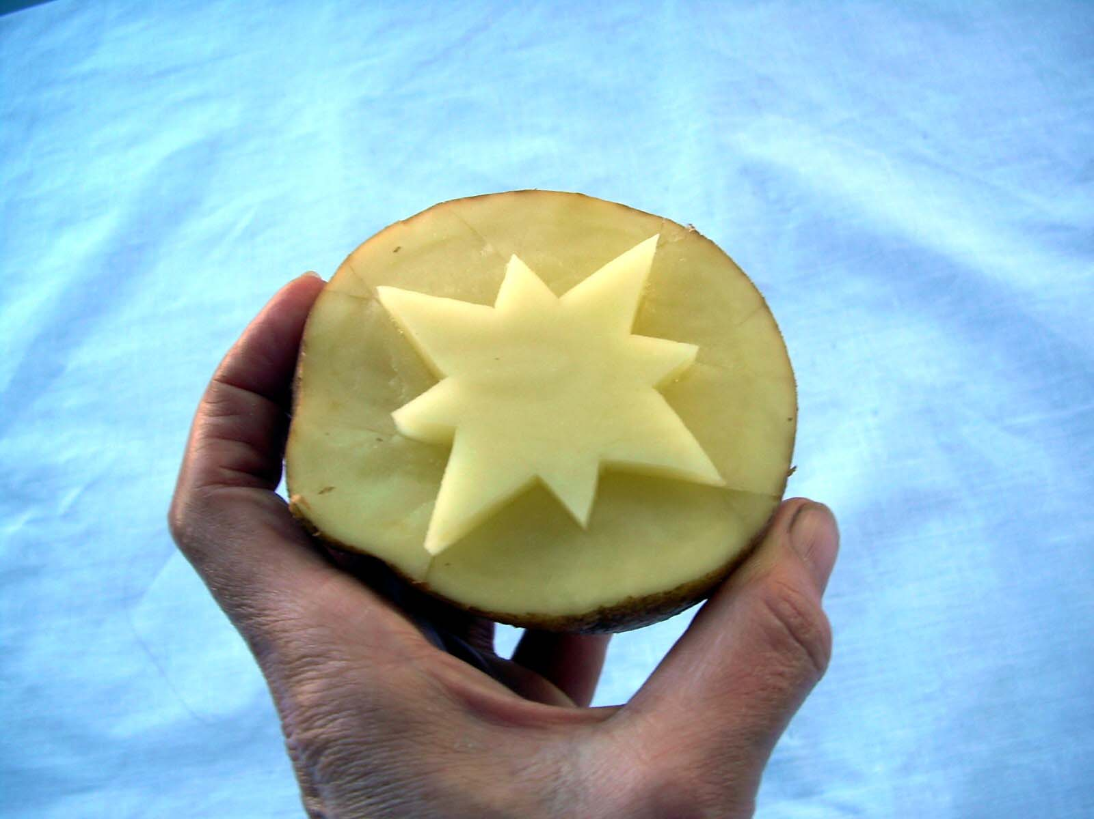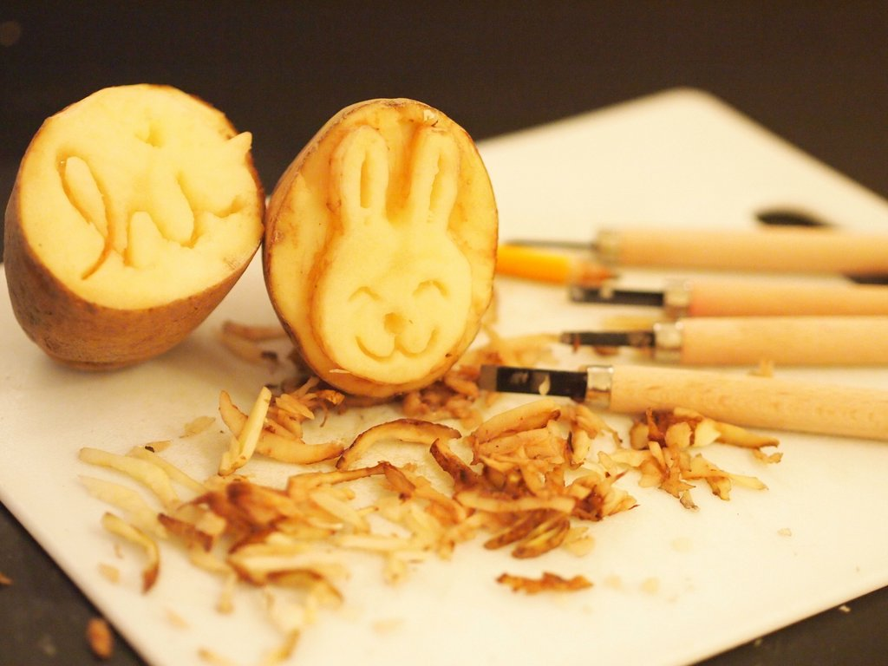
- Present data gathered on the number of lines of symmetry of given shapes in a variety of ways on picto-, bar, line graph etc.
- Determine the perimeter and area of each given shape using grid/graph sheet.
- Create group Powerpoints for Apps or games on their understanding of lines of symmetry.
- Publish their innovative designs and patterns that were created in school magazine, children’s own and or math competitions.
Links to other Subjects:
- Visual Arts: Blobbing, Designs and Shapes, Elements and Principles
- Engineering/Social Studies: Buildings and Physical Infrastructures
- Language Arts: Journal Writing, Publishing, Vocabulary building, (Synonyms/Antonyms)
- ICT: Using App. to manipulate designs of shapes
- Business Basics: Creating Logos and Emblems, Designing Advertisements
- Civics: Demonstrating Appreciation and Respect for others
- Physical Education: Shapes, Forms, and Movements
- Science: Classification of Foods, Textures, Shapes
- Home and Family: Culinary Arts, Foods and Presentation

