Subject: Mathematics
Content Strand: Geometry
Grade Level: Grade 2
Duration: 1 hour
Topic: Identifying Shapes

Standard:
Explore paths, geometric shapes, space and make generalization about geometric relationships within the environment.

Attainment Target:
Identify, describe and compare geometric figures and their properties.

Specific Objectives

At the end of the lesson, pupils should be able to:

- Identify simple geometric shapes observed in the environment (circle, rectangle, square, triangle)
- State two properties of the circle, square, rectangle and triangle through exploration

Prerequisite Knowledge

Students should already have:

- a general idea that all objects have a shape,
- be familiar with basic shapes in the environment

Materials/Manipulatives

Cut-outs: squares, triangles, rectangles, crayons, solid shapes (cube, cuboid, triangular prism, sphere, cone), geo-puzzle, pictures (depicting geometric outlines)

Content Outline

Lines and shapes are used in our environment to create and design buildings and things around us. These shapes are created by bounded line segments.

Procedure

Engage

Students will be shown a picture(s); they will observe, identify and describe different shapes seen.
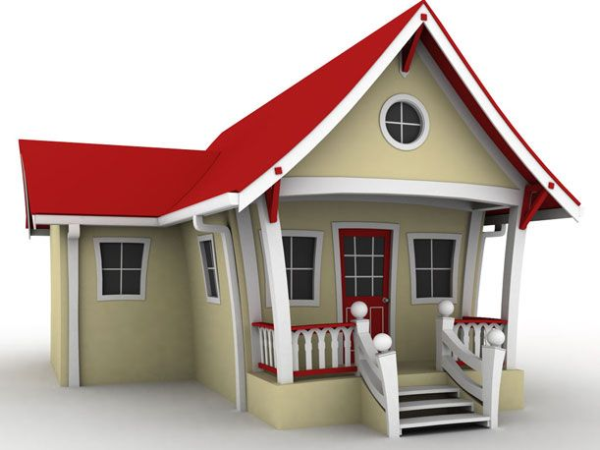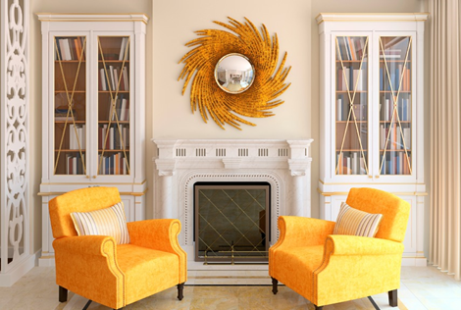

Explore

- Students will be given circular, rectangular (including squares) and triangular shapes in groups. Students will tell whether or not the shapes look like the ones in the house or in the classroom. They will be asked to sort the shapes in three groups based on similarities and differences.
- Students will rearrange tangram pieces to form rectangles, circles, squares, triangles.

Explanation

A discussion will ensue about how shapes are used to create particular designs in our environment. Students will give examples of these designs.
Questions:
- Which simple shapes can be seen all around us?
- Can you see shapes in your homes? Describe these shapes?
- Can you name some persons who normally work with shapes?
- How would you describe these shapes? (students are expected to list some properties of the shapes identified)

Extension
Students will be given cut-out of basic shapes to make a collage. Example could be the house below:
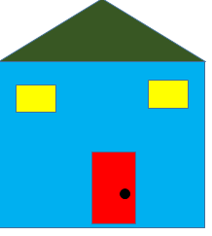

Evaluation

Shapes | Name | PROPERTIES OF BASIC SHAPES
Shapes | Name | I have no edges or sides | The lengths or each side is equal. | A four sided shape | a three sided shape | Opposite sides are equal in length | I have 3 corners | I have 4 corners
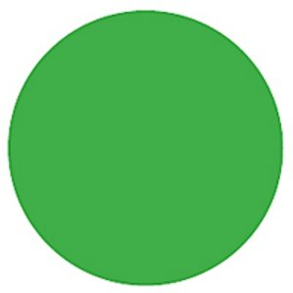

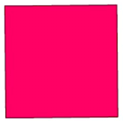



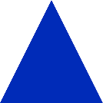

Instruction: Write the name of the shapes below, then put a tick on the properties that match the shape being described.

Materials

Tangram: Circle
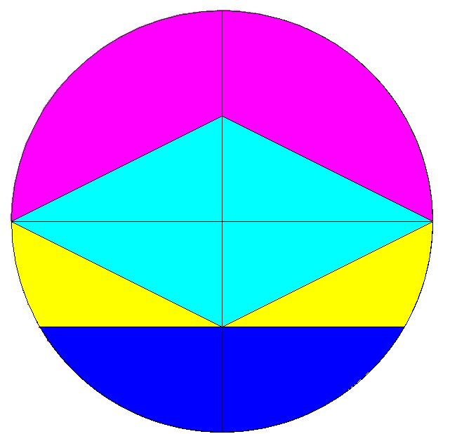

Tangram: Square
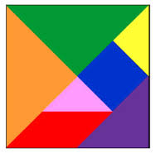

Tangram: Rectangle
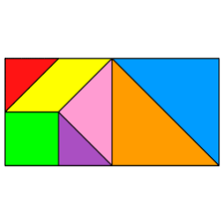

Tangram: Triangle



