Lesson 1
Grade: Two (2)
Subject: Mathematics
Strand: Geometry
Topic: Verifying and Exploring Line of Symmetry
Duration: 60 minutes
Objectives: by the end of the lesson students should be able to:
- Verify, line of symmetry through exploration
Pre-requisite Knowledge: Students should already know:
- The different kinds of polygons
- Fractional concept of halves
- Types of Paths
Materials:
Mirror, construction paper, polygon cut outs, symmetrical leave and pictures of object, paint.
Content:
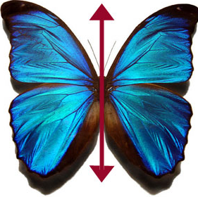
Symmetry can be classified as another name for reflection. One half is the reflection of the other half. The "Line of Symmetry"(the red line which cuts the butterfly) is the imaginary line where you could fold the image and have both halves match exactly.

Teaching and Learning:
Starter
Lesson will start using the game, “Where is my Half?” Polygons, pictures of objects and animals cut-outs will be cut in 2 parts – some will be cut into exact halves – and place in a small box and given to the class grouped in 4s. Competitively, each group is required to pick from the box 4 half cut – outs with their matching halves. They should place them on their desk. The first group to complete with 4 pairs of halves emerge the winner.

Development Activities
- Students will be given various sized leaves. Some will be symmetrical and some asymmetrical. They will examine and share with the class what they notice with the leaves. They will fold the leaves length wise and share what they notice.
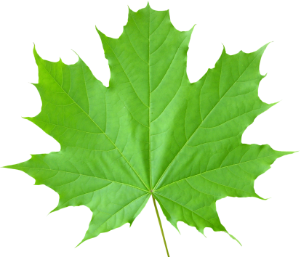

- When folded, one side of the leave should match exactly unto the other side. Students will be guided to discover that the vein which separates each side of the can be referred to as a line of symmetry.
- Based on what the main vein does to the leave students will share with the class what they think defines a line of symmetry. Students will justify their statement.
- In groups, students will fold a sheet of construction paper whether vertically, horizontally or diagonally so that one half matches exactly unto the other half. Students will open the folded paper and share with the class what they have noticed. One side should match exactly unto the other side or divides it into two identical halves or parts. The crease or fold indicates the line of symmetry or a line of reflection.

- The fold should look similar to the two pictures below.

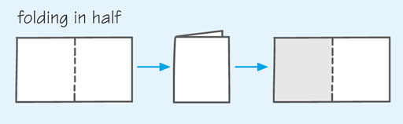

- Students will place a tip of paint in the crease of the paper. They will close the paper and glide the tip of fingers along the closed crease and over the surface until all the paint is absorbed in the paper.
- Students will open paper to see what figure or object is formed from this activity. They will examine and share with the class what they noticed. They also will give reason for their findings.
- For further exploration of line of symmetry, students will rest a mirror on the crease and share with the class what they noticed in the mirror. They should realise that an image of the object is reflected in the mirror. The point at which the mirror meets the object is called a line of reflection.
Assessment:
In the same groups, students will look around in the classroom, identify and record the objects that have a line of symmetry. They will also think of things they noticed while travelling to and from home that are symmetrical and record it.
For home work, students will take pictures of objects from their homes that are symmetrical. These will be glued in their journals.
Plenary
Students will be asked orally the following questions:
- What do you understand from the term “line of symmetry”?
- Can you identify some objects or things that are symmetrical?
- At what point can you say that an object/thing is symmetrical?

