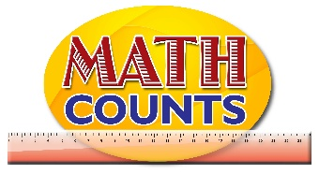

National Mathematics Team
Grade 1 – Planning Sessions Template

Strand: Geometry
Topics/Objectives | Main Concept | Teaching/Learning Activities | Assessment/Homework Activities
Identify and name  geometric shapes  observed in the  environment  (circle, rectangle, square, triangle). | Shapes  Triangle  rectangle  square  circle  straight  Sides  Curved or round  Corners  Length  Two dimensional | - Prepare a small non transparent bag with cards. On each card is a shape. (See resource document ‘two dimensional shapes’)  - Allow a few students to reach in the bag one at a time and select a card.  - Ask students to describe the shapes by asking questions, such as:  “What is the name of this shape? How do you know?”  “How many sides does this shape have?”  “How many corners does this shape have?”  “Are any of the shapes alike? How are they alike?”  “Choose two different shapes. How are they different?”  - As students discuss the shapes, record relevant vocabulary and drawings about shapes on the board or on a chart paper. For example:  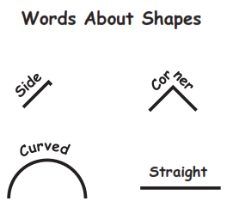  - Give students a copy of the Shape Hunt recording sheets (See resource document ‘shape hunt’).Pair up students or divide the class into small groups. Tell students that they are going on a “shape hunt” in search of real-world objects in the classroom that look like each of the shapes on the recording sheet.  - Model the activity by finding one of the shapes on the recording sheet. To organize the hunt, call out one shape at a time and give groups or pairs of students two to three minutes to search for objects that match that shape. Then have students return to their seats to discuss their findings. | - Observe students using a checklist, to assess how well they:  • identify two-dimensional shapes;  • describe two-dimensional shapes using appropriate vocabulary;  • identify two-dimensional shapes given oral descriptions;  • identify shapes by their attributes (e.g., number of sides).  - Arrange students in a circle. Provide each student with a card with an image of a shape (triangle, circle, square, rectangle):  Have students hold up their card if it matches the statement you make. Provide statements, such as the following:  “Show your shape if it has three sides.”  “Show your shape if it has a curved side.”  “Show your shape if it is a triangle.”  “Show your shape if it has a square corner.”  “Show your shape if it has two long sides and two short sides.”  - Have students glue shape cut outs to make pictures of  objects or draw pictures of objects using selected shapes. See resource document ‘make an object’  ICT Inclusion  On this website students identify shapes on things that are found in the environment.  http://www.harcourtschool.com/activity/solid_figures_plane_shapes/

Strand: Statistics
Week | Topics/Objectives | Main Concept | Teaching/Learning Activities | Assessment/Homework Activities
Week 4 | 2.Collect, sort and group data using attributes closely related to students to classify data:  Number of boys/girls  Clothing  Number of pencils  Birthdays  Height (tall or short).  Make general statements and draw conclusions based on information collected. | Table  Graph | 6. Provide a chart listing the shapes (circle, triangle, square, and rectangle) and have students go to the board to place a sticker beside their favourite shape. Engage students in a discussion using the following questions:  How many students prefer square?  Which of the shape is liked the most……?  Why do you think ….. is the least  favoured shape?  7. Organize students in groups and give each group a survey question. They will question each other using the survey question and use simple materials to organize the data collected. See resource document survey questions for further details  8.Give students a blank pictograph with all or some of the months of the year on cartridge paper; this will be attached to the board. Ask students to indicate the month they were born in by raising their hands if their month is listed on the chart. Give each student a cut out of a smiley face and have them go to the board to paste their smiley face at their selected month. Discuss with students how to read and interpret pictographs. | 1. Have students complete activity  sheet on shading bar graph to  represent data from the  ‘Animal Farm’. See resource document “Animals on the farm’  2. Give students worksheet on  reading and analyzing  pictographs. See resource document

Strand: Number’s cont.
Week | Topics/Objectives | Main Concept | Teaching/Learning Activities | Assessment/Homework Activities

