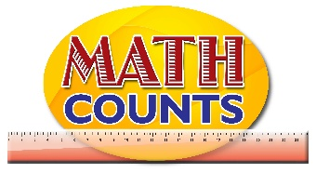

National Mathematics Team
Grade 1 – Planning Sessions Template
Topics/Objectives | Main Concept | Teaching/Learning Activities | Assessment/Homework Activities
- Describe simple fraction using words  - Identify halves of a whole  - Identify quarters of a whole | - Equal  - Fractions  - Halves  - Quarters  - Whole  - Share  - Fair | - Describe simple fraction using words  Have students listen to the story (either on YouTube @ (https://www.youtube.com/watch?v=hVaxiJB6Fls) or See Resource Document) “Give Me Half” by Stuart J. Murphy. Have discussions before the story is read, while the story is being read and after the story is read. Discussions may include what they think the story is about, what problem arise in the story, how they think it can be solved, what was done to solve the problem and what will happen next. At the end of the story, have students sort various examples into the headings fractions and non-fractions.  Students may be provided with a table (on the board or on a chart) and each student given a picture (prepare the picture by placing tape behind it beforehand). Students will go up and place the picture under the appropriate heading.  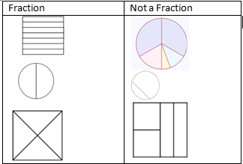  b. Identify halves of a whole  Provide students with rectangular paper strips (20 cm long) or perfectly shaped circular papers. Have students fold the paper into two equal parts. Have students unfold the paper and have a discussion about what is seen. Suggested questions:  - How many parts are you seeing?  - How many creases are on the paper?  - Are the parts equal?  - If you should remove one part of the two parts, what fraction did you remove? What fraction is left?  - How many halves make a whole?  Guide students into writing the fractions as$\frac{1}{2}$ and have them label each half of their paper. Have a discussion about how the number is written.  Ask:  - What do you think the 1 means? Or Why did we use the numeral 1?  - What do you think the 2 means? Or Why did we use the numeral 2?  - Identify quarters of a whole  Have students repeat the activity used to identify halves. Provide students with rectangular paper strips (20 cm long) or perfectly shaped circular papers. Have students fold the paper into two halves, and then halves again. Before asking the students to unfold the paper, have a discussion with the students. Suggested questions:  - How many parts will you see when you unfold the paper?  - How many creases will there be?  Have the students unfold the paper and count the number of parts and creases to see if their predictions were correct then continue the discussion. Suggested questions:  - If you should remove one part of the four parts, what fraction did you remove? What fraction is left?  - If you should remove two part of the four parts, what fraction did you remove? What fraction is left?  - How many fourths make a whole  - How do you think we would write one-fourth, three-fourths (quarters), two-fourths using numerals?  Have students label each quarter of their paper. | - Describe simple fraction using words  Have students create and share their own story similar to “Give Me Half” that explains their understanding of fractions.  - Identify halves of a whole and  - Identify quarters of a whole  ICT inclusion: http://www.snappymaths.com/counting/fractions/interactive/halfquartersimm/halfquartersimm.htm. This activity requires students to identify halves and quarters.
- Identify halves of a set of objects  - Identify quarter of a set of objects  - Read and write simple fractions (quarter and halves) |  | - Identify halves of a set of objects  - Read and write simple fractions (quarter and halves)  Provide students with sets of 10 items (may use counters, pencils, coins, stones, bottle cover etc.) Provide students with a “Half-Whole” mat (See Resource Document for sample). Have students place the 10 items in the section representing the whole. Have students count the items and write the number in the space provided. Ask students:  - What does it mean to share in halves?  - Can the items you have be shared in halves?  Have students share the items in the halves section of the mat so that the number of items in each section represents half of the whole amounts. Ask students:  - How many did you start with?  - How many are in each half section?  - What is one half of 10?  Have students repeat the activity using other number of items (6, 24, 12, 20). After each number is used have students draw the final product in their books and write explanations for each. Eg.  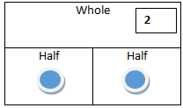  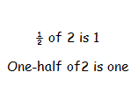  Extension: Have students place 4 items in one half section of the mat and ask the students to find the whole amount.  - Identify quarter of a set of objects  - Read and write simple fractions (quarter and halves)  Provide students with sets of 12 items (may use counters, pencils, coins, stones, bottle cover etc.) Provide students with a “Quarter-Whole” mats (See Resource Document for sample). Have students place the 12 items in the section representing the whole. Have students count the items and write the number in the space provided. Ask students:  - What does it mean to share in quarters?  - Can the items you have be shared in quarters?  Have students share the items in the quarters section of the mat so that the number of items in each section represents quarter of the whole amounts. Ask students:  - How many did you start with?  - How many are in each quarter section?  - What is one quarter of 12?  Have students repeat the activity using other number of items (8, 24, 16, 20). After each number is used have students draw the final product in their books and write explanations for each. Eg.  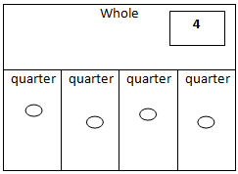  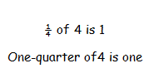  Have students find two-quarters and three-quarters of the same numbers.  Extension: Have students place 7 items in one half section of the mat and ask the students to find the whole amount.

