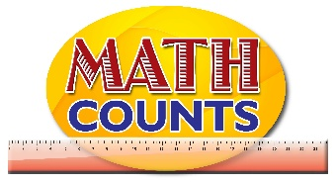
National Mathematics Team
Grade 1 – Planning Sessions Template
Topics/Objectives | Main Concept | Teaching/Learning Activities | Assessment/Homework Activities
Compare and order objects by their linear measurements using the same non-standard units.  Eg using a length of string equal to the length of your forearm, work with a partner to find other objects that are about the same length | Compare  Order  Linear  Non-standard unit  Length | Activity 1  - Tape a piece of chord / string that is 40cm long on the board or on a cartridge paper in a coiled position and a chord that is 30 cm long in a straightened position. If possible use different colour chords. Tell the students that the pieces of string represent snakes. Ask them to look at the snakes and estimate which snake is longer. Have the students explain their thinking. Ask:  - “How could we find out which snake is longer?”  - Invite students to demonstrate their strategies for comparing the lengths of the snakes. Some students might compare the lengths directly, by extending both strings and placing them side by side. Discuss how both strings need to be straight and how they must have the same starting point.  - Present some items on the teacher’s desk ( such as a piece of clothing, ruler (30Cm), text book, bag, shoes, toys, large envelop etc).  - Select students to measure items and decided which ones are just as long as the 30cm chord. Students can also measure there body parts with the chord/string eg. The length of the arm (from shoulder to wrist).  (Students will say the string is just as long as______)  Activity 2  - Put students in pairs and have them play a game of ‘Guess My Measure’. See page 3 of the Resource Document for game details.  Activity 3  - Take students outside and have them use non- standard units to measure various objects. For example: length and width of vehicles, length of leaves, sides of football field and netball court, width of the main gate etc. | Activity 2  Which Object Measures…  Provide students with several objects which meet a particular length.  Provide them with a checklist on which they will draw/identify the item that meets a particular measure.  See page 2 of the Resource Document for the activity.  Activity 3 - ICT inclusion  Integer Bars - http://britton.disted.camosun.bc.ca/integers/integers.html  This applet can be used to reinforce their understanding of non-standard systems of measurement.

