TOPIC: GENERATING NUMBER PATTERNS
Grade 5
DURATION: 1 hour
GRADE: Grade 5
DURATION: 1 hour
SPECIFIC OBJECTIVES:
By the end of the lesson, students will be able to:
- Generate number patterns
- Identify rules governing generated number patterns and express them algebraically
PREREQUISITE KNOWLEDGE
Students should be able to:
- express simple sentences and word problems as algebraic expressions
- recognize simple number patterns particularly those dealing with the multiplication operation
MATERIALS/MANIPULATIVES
At least 60 counters (30 of one colour and 30 of another)

CONTENT OUTLINE
Algebraic expressions can be used to describe relationships between two quantities. Once we know the relationship between the two quantities then we can determine the value of one quantity as long as we know the other. We do this by substituting known values into expressions.

PROCEDURE
ENGAGE
Two volunteers will be selected to model the following problem with the assistance of the class.
A boy and a girl sit on chairs separated by 1 chair.

What is the minimum number of moves needed for them to switch places following these rules?
- A person can either move onto an adjacent chair or "jump" over an adjacent person (of any gender) to the vacant chair immediately beyond him or her.
- Persons can move in one direction only – they are not allowed to turn back.
- At all times, a person must be on a chair.

Move 1
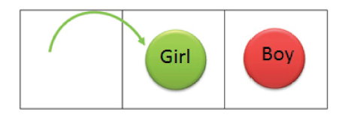

Move 2
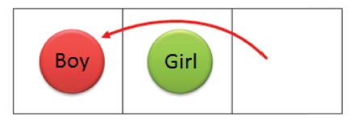

Move 3
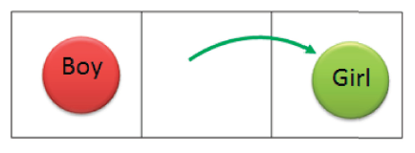

EXPLAIN
As a class, determine the minimum number of moves needed for 4 students (2 on each side) to exchange places (see model solution below).
Discuss the attempts made by the students by asking them
- to talk about the strategies they used
- say how they are sure that no fewer moves could have been used
Tell students that a minimum of 15 moves are needed for 3 girls and 3 boys to exchange places. Ask 6 volunteers to demonstrate how this is done. Allow the class to help them.
EXPLORE AND EXPLAIN
The teacher will place students in groups and give each group a pre-prepared table as shown below (Table 1). From here, students will be asked to predict, or work out using counters, the minimum number of moves needed for 8 persons – 4 on each side – to exchange places and to complete the table up to the point where 6 persons are on each side.
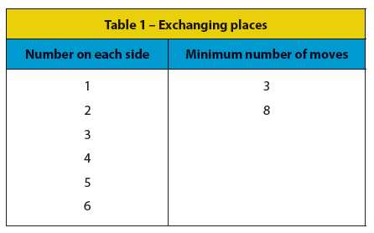

Ensure that all tables are completed correctly up to this point (as shown in Table 2 below).
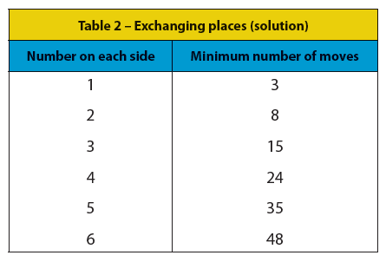

If students are having challenges completing the table, guide them by asking questions such as:
- By how much does the minimum number of moves increase in each case?
- Is it a constant number? What is special about the numbers by which it increases in each case?
- Can you use this to predict the minimum number of moves for other cases?
After students have completed their tables, ask them to say the minimum number of moves if there are 36 on each side.
Discuss why this is a difficult question to answer. Ask them to explore the relationship between the number on each side and the minimum number of moves required. If necessary, ask guiding questions such as:
- What are some of the operations you can perform on 1 to get 3?
- Is there a similar operation that can be performed on 2 to get 8?
- Look at the other corresponding pairs. Is this true for all pairs?

EXTEND AND EXPLAIN
On the board write:
1 is multiplied by 3 to get 3
2 is multiplied by 4 to get 8
3 is multiplied by ___ to get 15
4 is multiplied by ___ to get 24
6 is multiplied by ___ to get 48
9 is multiplied by ___ to get ___

EVALUATE
Write a sentence that describes the relationship between numbers on each side and the minimum number of moves?
Let n represent the number on each side, and write an algebraic expression for the sentence they wrote?
Tell what number will 36 be multiplied to get the minimum number of moves?
By what numbers will the following numbers be multiplied?
- 19
- 25
Discuss the various solutions that the groups came up with. Ensure that the relationship is clearly understood.

